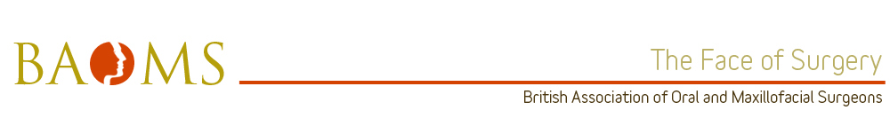

Trainer of the year nomination South Wales

Mr. Adrian W. Sugar

Leadership
AWS is a strong and enthusiastic leader both clinically and academically. He is inspirational in his commitment to ensuring the best outcomes for patients and strives to maximise learning opportunities for trainees.
I feel that AWS allows appropriate responsibility and encourages independent thinking, whilst being a fully supportive approachable leader. He is a role model for any aspiring maxillofacial trainee.
Resourcefulness
As a supervising consultant AWS stresses the importance of ownership and responsibility of patient care. AWS is very proactive in teaching and encouraging in the treatment planning of cases and will allow trainees to explore options before intervening. He always strikes an excellent balance between support and encouragement during operations'.
Training and development
AWS has been an instrumental member in training and development in South Wales for over 20 years. He has tirelessly supported his trainees in all aspects of theirs lives and his door has always been open to discuss anything from difficult cases to cycling! AWS has always delivered the best possible training often in the face of other hospital pressures and his trainees past and present are forever grateful.
Professionalism
Mr. Sugar is very highly committed to his work, his professionalism, desire and attitude are model that juniors, and seniors a like, aspire to achieve. AWS levels have never dropped to below an absolute maximum, he works tirelessly and enthusiastically to achieve perfection for his patients and never accept second best.
Communication
When it comes to communication, AWS is the master. He never hesitates to spend as much time as he needs to ensure that each patient receives nothing less than what they deserve, he possesses a magnificent ability to communicate very efficiently with patients of all age groups.
AWS is never rushed when approached by any of his colleagues, His great communication ability provided trainees the opportunity and the privilege of gaining wealth of knowledge which, throughout the years, has helped and is still helping to produce excellent OMFS surgeons.

