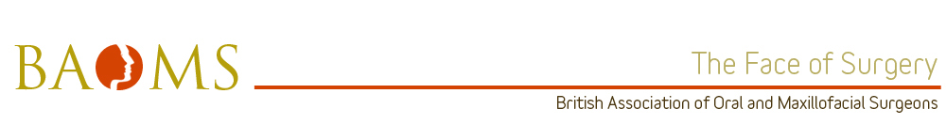

Mr Stephen Walsh MEd FRCSEd(OMFS) FDSRCS FFSTEd – KSS
Mr Walsh is a Consultant OMF Surgeon at Western Sussex Hospitals NHS Foundation Trust. He is a Fellow of the Faculty of Surgical Trainers for the Royal College of Surgeons of Edinburgh and holds a Masters in Surgical Education. His genuine passion and enthusiasm for training is tangible and is therefore well deserving of the title “BAOMS trainer of the year”.
Leadership
- Mr Walsh is a committed and enthusiastic educational supervisor for specialty trainees. He takes on this role with enthusiasm and empathy which is great for developing the confidence of junior trainees.
- He is the educational lead for the Dental Core Trainees (DCTs) within the trust and leads the departmental weekly teaching sessions. He has an integral role in the training of DCTs at a deanery level particularly in the assessment of course work for their diploma.
- He is clinical tutor for medical students within the trust and, having sat in on his teaching sessions, he is fantastic at maintaining a friendly and informal atmosphere.
- Mr Walsh has also been the Leadership Tutor for the trust and is keen on giving feedback and developing leadership qualities in his trainees.
- Mr Walsh is the current Chairman of the Chichester, Bognor Regis & District British Dental Association as well as Departmental Lead for Clinical Audit.
Training & Development
Mr Walsh has been a trainer for a relatively short period of five years however he has managed to achieve so much during this time. His teaching style is best described as Socratic as he is great at stimulating debate and promoting a critical way of thinking. He is an Educational Supervisor to KSS trainees and regularly sits on the ARCP panel for both KSS and Wessex Deaneries. It is obvious from meeting him that training is something which is always at the forefront of his mind. He has an open and honest approach to training and regularly discusses cases using his extensive catalogue of clinical photographs. He reflects on his outcomes and brings trainees into the discussion which is an incredibly powerful teaching tool. He is enthusiastic about work based assessments and it is not uncommon for him to remind trainees that they haven’t done any in a while! Of course this means that none of his trainees arrive at their ARCP with deficient numbers to pass with a good outcome. His enthusiasm also extends to the DCTs and he is always mindful of their individual educational needs, he does this by keeping an open dialogue with them.
Professionalism
As one can see from the list above, Mr Walsh has many roles both educational and managerial. Clinically he is a great role model for teamwork as no task is beneath him and he values the input of all members of team. He puts the needs of his patients and is very mindful of doing the ‘little things’ like staggering the arrival times of his patients for theatre so they don’t wait around too long or ringing the family after their loved one’s surgery to put their mind at ease. Trainees think of him as a great role model for professionalism due to these characteristics.
Resourcefulness
Mr Walsh achieves high standards in his many roles which make him a very valued and respected clinician. One can easily recognise how resourceful he needs to be in order to maintain his busy clinical practice as well as all his non-clinical duties. Despite this incredibly busy schedule he always makes time for people.
Communication
Mr Walsh is a great teacher and as such has fantastic communication skills. From his friendly approach to teaching medical students to chairing local BDA meetings and MDTs Mr Walsh is a master of adapting his communication style to his environment. He has a large back catalogue of funny anecdotes from his experiences during training and is a pleasure to work with.

