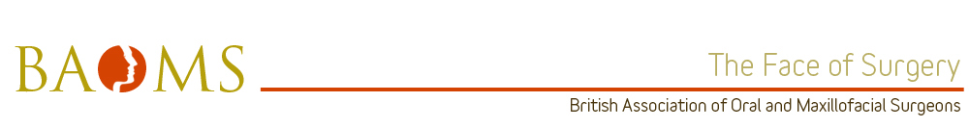

Nomination for Trainer of the Year 2014 – Oxford Deanery Mr Andrew Currie
Oxford University Hospitals (Named Deformity Surgeon).

The trainees in the Oxford rotation would like to nominate Mr Andrew Currie for BAOMS Trainer of the Year 2014. His devotion to training is exceptional. He creates a trainee centred learning environment to promote progression of technical and clinical skills based on each trainee educational needs. His approach to training combines pragmatism and fairness, leadership and empowerment, professionalism with humour.
Leadership in Training
Mr Currie’s approach to training builds up on trainee’s previous experience and he would divide each surgical procedure into stages and once a trainee achieves one stage he would guide them to the next one. Training under his supervision is never the same as the trainee can feel their competency progression from one theatre session to the next. As a clinical supervisor, Mr Currie always ensures that time is given for trainees to question suggested treatment plans and engage in an exchange of ideas. Trainee suggestions are never met with criticism. Encouragement is given to formulate management of both simple and complex cases. As well as promoting a collaborative approach with trainees his leadership is inclusive of different surgical, medical and other members of the team. Understandably, this was not the easiest to achieve due to different backgrounds of team members, but he always manages to accomplish it with a smile.
His subtle approach to management reassures his colleagues and is essential in giving confidence to his trainees. His subtlety is a perfect example to trainees on how to resolve difficult issues without getting in an argument with colleagues.t
Resourcefulness in Training
Opportunistic teaching is an integral part of Mr Currie’s clinical practice. Every clinical encounter is used to its maximum for patients and trainees' benefit. Creating time to allow trainees to operate under supervision without feeling pressure for time or performance is probably his greatest asset as a trainer. He maximises training whilst taking care to balance nursing staff working hours and waiting lists pressures. His operating lists always finish on time without the trainee feeling disadvantaged. In clinic he allows trainees to make decisions and discuss them with him from the first time they attend his clinics. Discussion and validation of formal work based assessments for his trainees are always taken in consideration.
Training and Development
Mr Currie does not limit his training to higher trainees in OMFS, he also trains dental and medical junior trainees. As an Educational Supervisor, he is extremely approachable and participates in the use of ISCP. He is a very supportive supervisor and mentor. Development of trainee’s skills in management, research and publications is always encouraged and supported by him.
Professionalism in Training
Mr Currie’s professional attitude is an example to be followed. He enjoys excellent work relationship with his colleagues of all levels and particularly trainees. He is calm, positive, and fair, even under difficult circumstances. When things are being difficult for a trainee he would always have a word of encouragement. He builds on what the trainee have and appreciate that each individual is different. His experience and knowledge of different aspects of life away from work makes him appreciate what trainees have to deal with outside work.
Communication
Mr Currie is very methodical in his teaching process and gives praise when deserved, feedback is always constructive and he welcomes the challenges of having trainees. His wise words in time of difficulty guide trainees to next appropriate stage of their training pathway. He would always encourage his trainees to develop their skills further and give them chance to achieve that. He enjoys an excellent relationship with his work colleagues and is very approachable.

