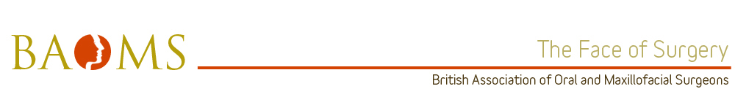

Ian Holland - Scotland

The voting Scottish trainees would like to nominate Mr Ian Holland for BAOMS trainer of the year. We believe Mr Holland would be a worthy recipient of this award.

Mr Holland is a modest, highly ethical, motivated, trustworthy and extremely hard working trainer, who is dedicated to his patients and trainees alike. As the Scottish training program director, a position which Mr Holland has held for several years, he has committed himself to improving training throughout his tenure, and remains an 'unsung hero' in our eyes.

Mr Holland is a hands on, enthusiastic and committed trainer who is exemplary as a supportive and collaborative colleague, actively encouraging his trainees to be the same. He always goes that 'extra mile' for his trainees throughout their journey, personally supporting them when Trusts or the training system have fallen short, and 'steps up' when other colleagues appear less enthusiastic. He actively engages and listens to the trainees and has a rare ability to view a situation from many angles and present an unbiased view. He gives his time freely without question, actively seeking solutions to problems/issues and provides his unyielding support. He ensures each trainee meets his professional training requirements, both in terms of the ISCP as well as career development and progression, ensuring that the other trainers engage in the process also.

Mr Holland ensures trainees are a principal member of the team, actively involving them in clinical decision making, taking a lead in the organisation of a busy service, taking shared ownership of patients and developing the skills required of a future consultant. He has performed many an operation on the power of trainee suggestion.

Mr Holland embodies personal, unlearned traits that make him a very genuine, caring surgeon, who's practice comprises a very difficult section of society, with chaotic lives. He goes the extra mile to accommodate their needs always looking after their best interests - a true role model.

