Pooled Patient Transport Services for the Head and Neck Multi-Disciplinary Team Clinic
By Michael Goodfellow¹, Andrew Burns²
- School of Dental Sciences, Newcastle University, Framlington Place, Newcastle Upon Tyne, NE2 4BW.
- Department of Oral & Maxillofacial Surgery, Sunderland Royal Hospital, Kayll Road, Sunderland, SR4 7TP, United Kingdom

Introduction
MDT clinics require a large group of patients commuting to a central specialist centre to receive input from multiple clinicians. Within the NHS, approximately 5% of total emissions originate from patient road transport to appointments.¹ The NHS “Delivering a 'Net Zero' National Health Service” document highlights that altering patients’ travel into hospital could save 461 kilo-tonnes of CO₂ equivalent every year.²
In large urban areas of the UK, 78% of all journeys within a car or private transport are for personal travel, including trips to hospital and healthcare appointments. In rural areas, this increases to 90% of all journeys with a car.³ A survey of GP patients found that most journeys made by patients for healthcare appointments were by a private car for relatively short journeys of under 2 miles.⁴ In a hospital setting, nearly 3000 tonnes of CO₂ of carbon emissions were prevented by changing in-person appointments to telemedicine visits during the COVID-19 pandemic.⁵ In one year, over 31 tonnes of CO₂ equivalent was emitted by patients commuting to an urban community hospital in New York City for cancer care.⁶
Non-emergency patient transport services deliver between 11 – 12 million patient journeys each year and cover half a million miles each weekday. Of these services, 45% are for patients attending outpatient appointments, and 75% of users are aged 65 or older. It is thought that patient transport emits 57 – 65 kilo-tonnes of CO₂ equivalent per year, approximately 20% of the NHS’ direct travel emissions.⁷
Although the importance of non-emergency patient transport services are highlighted for reducing health inequalities and improving patient access to care, there has been limited acknowledgement about how these services could be used to reduce patients’ carbon emissions for journeys to hospital. This will become even more pertinent in 2035, when 100% of vehicles used to deliver patient transport services are targeted to be zero emissions vehicles.
In this study, we model how creating a dedicated patient transport service for our Head & Neck MDT would allow us to reduce patient emissions and contribute towards a net zero NHS.

Methods and Materials
We performed a retrospective review of patients attending our tertiary centre’s MDT between October 2024 and December 2024. Patients were identified from our MDT clinic lists during these dates, and data were extracted including patient demographics and postcode information.
We wrote custom Python scripts which required the additional libraries Pandas and Requests. These scripts utilised the Googlemaps Geocode application programming interface (API), which obtained longitude and latitude data of each patient, and the Googlemaps Directions API. The Directions API generates a .JSON file containing information about a journey between two locations, following the most efficient route and incorporating historical traffic data.
Using these scripts, we generated matrices containing travel data for journeys between each patient. The matrices contained the distances for a patient transport services bus commuting between each patient, and the time it would take that journey in minutes. These journeys were programmed to commence at 09:30 am on a Thursday morning to reflect anticipated traffic during a typical day and time when our MDT would occur.
We then used a nearest neighbour algorithm to generate a list of patients for each week of the MDT who could commute by a patient transport service. Patients were chosen to limit the total distance travelled by the patient transport service, and therefore limit carbon emissions, whilst limiting the increase in journey time. We modelled collecting three, four and five patients to allow space for relatives also attending the MDT. The patient transport bus had an optimal pickup route calculated by OpenRouteService.
We created two models of our patient transport service. One model selected patients without regard for their consultant and focussed on minimising journey times. The other only selected patients for the transport if they had unique consultants, whilst still optimising journey distance reduction. Choosing patients with unique consultants meant that the patients in the transport would have a minimal delay at hospital before commencing on their return journey home.
The vehicles currently used by our Trust to deliver non-emergency transport services are not zero emission vehicles. For carbon emission calculations, we have assumed that the emissions per kilometre travelled will be equal between our patient transport service and a patient’s private transport vehicle. Carbon emission reductions are therefore a function of the total journey distance saved by having a service collect multiple patients, rather than all patients commuting to hospital individually.
Simple descriptive analysis of our data was performed using custom Python scripts with the statistical libraries Pandas, SciPy and Numpy. Graphs were generated using Python scripts with the Matplotlib library.

Results
Our MDT had a total of 299 clinic appointments over 10 weeks for 256 unique patients. The mean age of patients was 65.4 ± 11.5 years, 69.6% were male and 30.4% were female. The number of consultants in our MDT ranged from 4 – 7 and 19 – 37 patients were reviewed each week.
For a single week of the MDT, the mean one-way travel distance of every patient commuting privately by car was 535.9 ± 88.7 km, or approximately 0.18 tonnes of CO₂ equivalent.

Optimising for Journey Reduction
When modelling a patient transport bus which collected three, four and five patients, and allowed for a single consultant to see multiple patients in the transport, we were able to save a mean of 12.7 km, 25.0 km and 33.3 km (Figure 1) travelled. This would reduce the average travel emissions of all patients travelling to the MDT each week by 2.5%, 4.9% and 6.5% respectively. On an individual patient level, the mean carbon emissions of the patients in the transport would be reduced by 18.9%, 27.1% and 33.1% respectively. This would increase the average journey time for the patient collected first by a maximum of 5.9, 14.9 and 21.6 minutes respectively (Figure 1).
In this model, a single consultant would only see at most two patients in the patient transport, and this would occur in 60% of journeys modelled. Given each appointment is scheduled for 20 minutes, this could represent an additional delay of 20 minutes before the transport service is able to commence its return journey.

Optimising to Prevent Consultant Clashes
When we created a model which collected patients who all had unique consultants at the MDT, we would not be able to run a transport service that collected five patients in two of the ten weeks, without increasing the total journey distance travelled. During the remaining weeks, for a transport bus collecting three, four and five patients, we would be able to save a mean journey distance of 10.6 km, 19.3 km and 25.9 km respectively (Figure 2).
The average travel emissions of all patients travelling to the MDT would be reduced by 2.1%, 3.5% and 4.4% respectively, but the individual patients’ carbon emissions would be reduced by 17.9%, 23.5% and 26.3% respectively. This model would increase the average journey time for the patient collected first by 4.6, 16 and 26.4 minutes respectively (Figure 2).

Discussion
MDT clinics have substantial carbon emissions associated with patient commuting. An average week of our head and neck MDT saw approximately 0.18 tonnes of CO₂ equivalent emitted by patients commuting for a one-way journey. Head and Neck cancer is the 8th most common cancer in the UK, and therefore larger MDTs such as breast cancer and bowel cancer could have substantially more emissions associated with patient commutes.⁸
Selecting patients for a multi-pickup patient transport service would reduce total road travel whilst only marginally increasing patient journey time. Our models allow the optimal patients to be selected for these transport services; however, it would require patient engagement and buy in. Other factors such as the consultant caring for each patient to would need to be accounted for. As demonstrated above, disregarding each patient’s consultant would save more journey kilometres, however patients would have to wait longer for the return journey, as a consultant cannot see two patients at once.
Multi-pickup patient transport services could be an effective intervention to help reduce the total distances travelled by patients when commuting to hospital and therefore help the NHS reach its net zero goal. Furthermore, when all patient transport service vehicles are zero emission by 2035, this will further reduce the total CO₂ emissions of those patients travelling to our MDT to zero for that journey.⁷
Just 3% of cars registered in the UK were battery electric in June 2024, and the government’s zero emission vehicle mandate specifies that by 2035, 100% of all new car sales must be zero emission vehicles.⁹ However, given the average lifetime of a car in Western Europe is 18.1 years, we expect emissions savings will still occur by utilising non-emergency patient transport long after the 2035 deadline.¹⁰

Limitations
We have not modelled an increased time for a stationary bus whilst a patient is being picked up, leading to longer commute times than identified here. Furthermore, patient appointment times vary, therefore patients on the transport service may need to wait for all participants to complete their consultations before embarking on their return journey.
This must be balanced with the benefits of using a transport service over a private vehicle, however. For example, patients would not need to spend time identifying a parking space and then commuting from the carpark to the outpatient department. Patients would also not have to spend money on parking whilst they attend their appointment.
Additionally, we have made assumptions that patients’ private vehicles will emit the same amount of carbon as our patient transport service per kilometre travelled. Some patients may already have zero-emissions vehicles, whereas others may have vehicles which pollute heavily.

Conclusion
In conclusion, we have generated a model that identifies patients to be collected by a patient transport service and a route to take those patients to hospital. This model will minimise additional commuting time and maximise journey kilometres saved, all with the hope of reducing patient transport carbon emissions.
This model is not just restricted to our centres’ Head and Neck MDT. The Python scripts written by our team can be utilised for other cancer MDTs and even other outpatient clinics, allowing carbon emission savings to occur specialty and country wide.

References
- NHS Sustainable Development Unit. Reducing the use of natural resources in health and social care. 2018. Available from URL: https://www.england.nhs.uk/2016/06/sustainable-development/. The Sustainable Development Unit for NHS England and Public Health England [last accessed 10 July 2025].
- NHS England. Delivering a 'Net Zero' National Health Service. 2022. Available from URL: https://www.england.nhs.uk/greenernhs/a/net/zero/nhs [last accessed 10 July 2025].
- Department for Transport. Travel in Urban and Rural areas. Personal Travel Factsheet — March 2010. 2011. Available from URL: https://assets.publishing.service.gov.uk/media/5a74886f40f0b616bcb173f8/Travel_in_urban_and_rural_areas_personal_travel_factsheet___March_2010.pdf [last accessed 10 July 2025]
- Andrews E, Pearson D, Kelly C, Stroud L, Perez MR. Carbon footprint of patient journeys through primary care: a mixed methods approach. The British Journal of General Practice. 2013 Aug 27;63(614):e595.
- Patel KB, Gonzalez BD, Turner K, Tabriz AA, Rollison DE, Robinson E, Naso C, Wang X, Spiess PE. Estimated carbon emissions savings with shifts from in-person visits to telemedicine for patients with cancer. JAMA Network Open. 2023 Jan 3;6(1):e2253788-.
- Yusuf H, Gor R, Saheed RM, Vegiventi C, Kumar A. Travel-associated carbon emissions of patients receiving cancer treatment from an urban safety net hospital. Future Healthcare Journal. 2024 Dec 1;11(4):100174.
- NHS England. Improving non-emergency patient transport services. Report of the non-emergency patient transport review. 2021. Available from URL: https://www.england.nhs.uk/wp-content/uploads/2021/08/B0682-fnal-report-of-the-non-emergency-patient-transport-review.pdf [last accessed 10 July 2025].
- Cancer Research UK. Cancer Incidence for Common Cancers. 2025. Available from URL: https://www.cancerresearchuk.org/health-professional/cancer-statistics/incidence/common-cancers-compared#heading-Zero [last accessed 10 July 2025].
- UK Parliament. House of Commons Library. Electric Vehicles and Infrastructure. June 2025. Available from URL: https://commonslibrary.parliament.uk/research-briefings/cbp-7480/ [last accessed 10 July 2025].
- Held M, Rosat N, Georges G, Pengg H, Boulouchos K. Lifespans of passenger cars in Europe: empirical modelling of fleet turnover dynamics. European Transport Research Review. 2021 Dec;13(1):9.

Figures
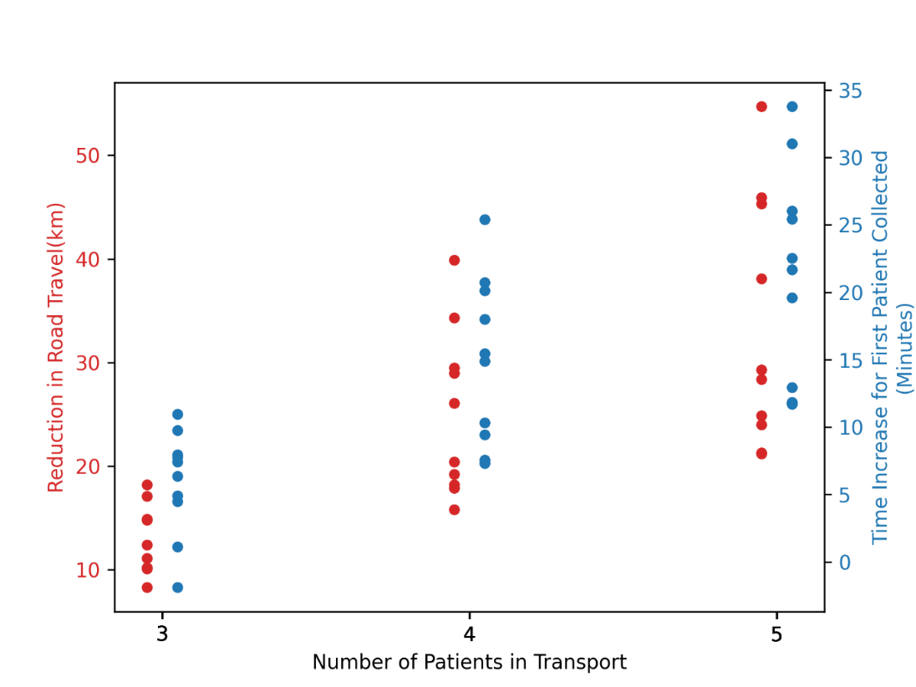
Figure 1: Travel Distance Saved and Corresponding Maximum Time Increase for Patients Travelling by Modelled Patient Transport
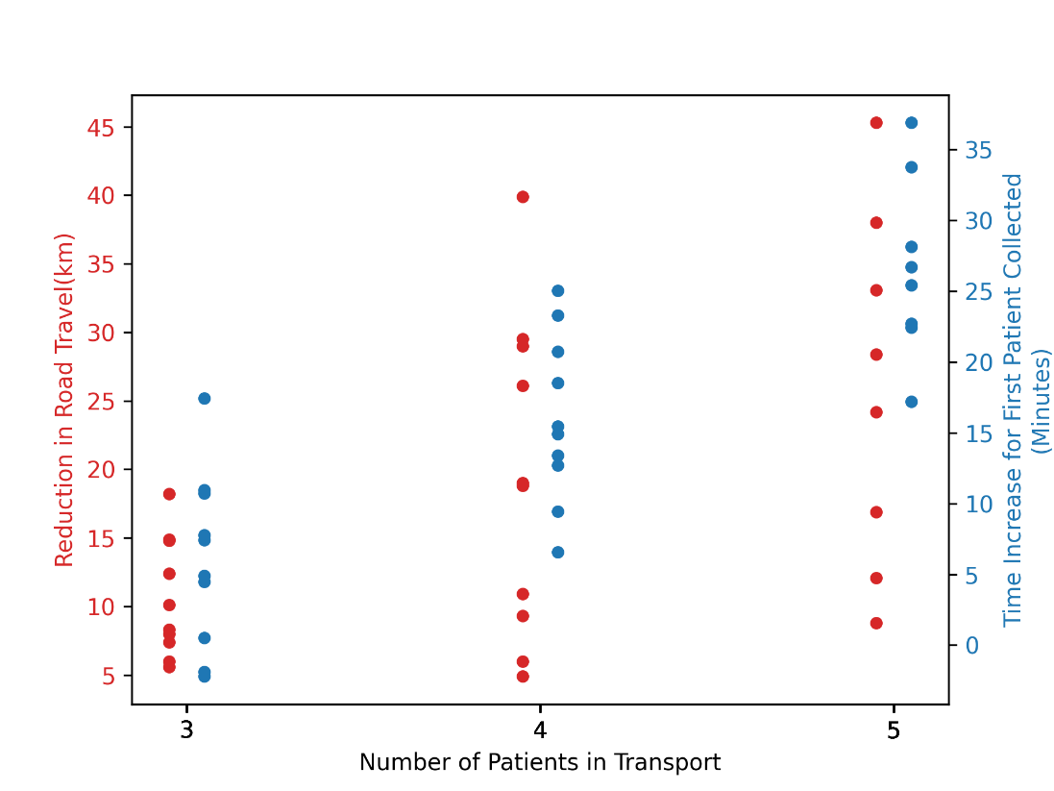
Figure 2: Travel Distance Saved and Corresponding Maximum Time Increase for Patients Travelling by Modelled Patient Transport When All Patients on the Transport have Unique Consultants.

