Student Finance for Second Degree Students

Introduction
Starting a second degree is a particularly daunting step in the career of a future maxillofacial surgeon. It’s a sizeable commitment just in terms of time and hard work but, unfortunately, second degree students face the additional pressure of supporting themselves through this period financially.
The idea of having to find the money to pay for university fees whilst giving up fulltime employment is very daunting. Multiple sources of financial support exist, but they are not always well-publicised, and the routes to funding are often different for graduate students or for mature students who are financially independent from their parents.
This guide aims to bring together the relevant information to give second degree one source which can give them a good understanding of the options available to them. The specific amounts of money offered by various organisations tend to differ slightly from year to year. However, the principles outlined here have stayed largely unchanged for many years.
P.S. If and when the time comes that this information is significantly out of date, updating it would be a perfect project proposal for the BAOMS bursary!

Things to pay for
The first thing to consider when looking at your finances is your outgoings. A lot of your income is likely to be from locum work, and it will be up to you to decide how much work you need to take on to cover your fixed, necessary costs. This section will outline those, and will discuss any ways you can arrange discounts at the source.
The next section will discuss ways to pay for all these things.

University Fees
University fees differ depending where you study and what your “home nation” is. Your home nation is considered to be the place you most recently lived, excluding time as full-time student. So, if you are originally from England, studied dentistry in Scotland and then stayed in Scotland for a DCT job, you are treated as a Scottish student. However, if you had studied in Scotland but then moved back to England to work, you are still treated as English.
The table below outlines the fees currently charged to students in the four constituent countries of the UK. Aside from Scottish students studying in Scotland, most students can expect to be charged around or just above £9000 per year of their course.
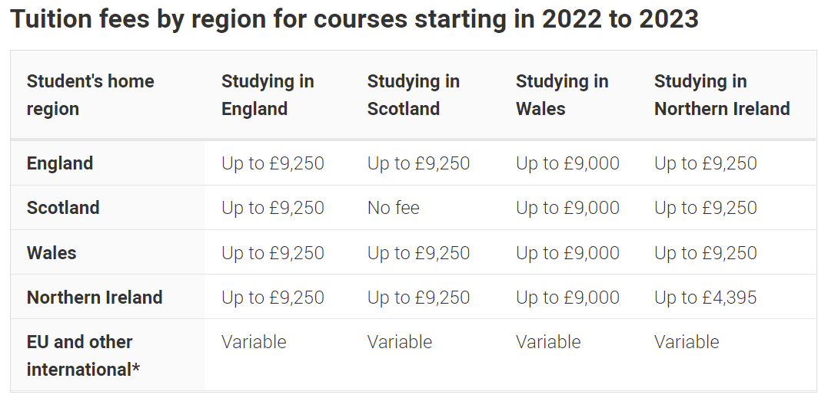Table showing tuition fees by region for courses starting in 2022/23, as found on the UCAS website: https://www.ucas.com/finance/undergraduate-tuition-fees-and-student-loans

GDC/GMC Membership
This is a necessary evil; to be able to continue working as either a dentist or a doctor during your second degree you will have to continue to pay your annual retention fee to either the GMC or GDC. Unfortunately, they do not offer discounts for second degree students.

Indemnity
If working alongside studies, you will need to arrange indemnity. This may be cheaper than for working full-time; calculate the average number of hours you are likely to work per week and request a quote based on this to ensure you aren’t overpaying. If asked to calculate “sessions” per week, a session is four hours. Indemnity can range wildly depending on the number of years since you qualified and the type of work you’re doing. If you’re considering doing any private work, make sure your earnings will consistently make up for the high indemnity fees you’ll be charged.

Professional memberships
Lots of professional bodies offer discounts or free memberships to students. Some may take your university acceptance letter as proof of student status. Others will need more formal proof, so make sure to get a formal “proof of student status” letter from your university as soon as you enroll for your first term.
BAOMS – Membership is free for students. Email the BAOMS office your acceptance letter once you secure your place, and they can apply student status to your account. This will also mean you are automatically invited to apply for the BAOMS bursary.
MFDS/MJDF – Rates are usually reduced or free for students. RCPS Glasgow, for example, waves all membership fees whilst you’re a full-time student. Email the membership team of your college to ask, and supply evidence of your student status.

Living costs
These obviously differ a lot between areas, so make sure to look at things like rent prices before making the decision to move to a new area for medical school. As a full-time student you are exempt from council tax; check your local council’s website for details of how to supply evidence of your student status. Remember to factor in transport costs to and from university and local OMFS units for work.

Other Discounts:
Lots of other student discounts are available:
- 16-25 railcard: Full-time students of any age can get a 16-25 railcard, which is a slightly better deal than a 26-30 railcard. Details here: https://www.16-25railcard.co.uk/help/faqs/mature-student/
- Look at student insurance companies etc. to compare deals – often good rates
- Student Beans, Unidays etc.

How to pay for Things:
Your main sources of income during your second degree will likely be student loans, NHS bursary, part time work and other bursaries, such as the BAOMS bursary.
Working out your entitlement for both student loans and NHS bursary can be tricky, and depends significantly on the structure of your course, and particularly how it is coded in the UCAS system. This section breaks down the different course types, and how these affect your finance entitlement.

Student Loans
The following are some important terms to understand before starting this process. The phrases “Year of Course” and “year of Study” get used a lot in applications for student finance, and depending on the structure of your course they could mean the same thing or be very different. It’s not exciting reading, but it’s worth taking a few minutes to read through the differences between these terms and work out which kind of course you’re on, to avoid wasting time having to re-do applications.

Year of Course vs Year of Study
Year of Course = Essentially, if a student started on day 1 of the course and continued on a normal path, which year would they be in?
Year of Study = How many years of this course have you personally participated in? When you join the course, you start your first year of study. Re-sitting a year would add an extra year of study.
For some courses these are different, right from the start. It all depends on how the university has set up the course. Specifically, the UCAS code, more than what happens in practice.
Your Student Finance and NHS Bursary entitlements are based on your Year of Course, so it’s important to understand if your Year of Course is different to your Year of Study to allow you to fill in the forms correctly the first time, and get all the finance you’re entitled to.

Courses Starting in Year 1
If your course has a special UCAS code just for OMFS applicants, it may be very straightforward. The course is registered as having a certain number of years of study, and OMFS applicants will attend all of them, starting in the first Year of Course. In this case, the Year of Course will be the same as the Year of Study. This also applies to second-degree students attending normal graduate entry medical and dental courses where they start in year 1 of the course.
Even though in practice students at these courses may appear to join a cohort who have already completed several years of study, if the course has a unique UCAS code it is considered a totally separate course for finance purposes. For example, somebody studying 3-year second degree medicine at Barts/QMUL appears to “join year three” of the undergraduate course, but in terms of codes they are starting the first year of the three-year A30X course. Their first year of study is the first year of their course.
As of entry year 2022/23 this is the case for the following courses:
Course | UCAS Code
Aberdeen – Graduate Entry Dentistry | A201
King’s College London – Graduate Entry Dentistry | A202
King’s College London – OMFS 2nd Degree Dentistry | A204
UCLAN – Graduate Entry Dentistry | A202
Cambridge - Graduate Entry Medicine | A101
Cardiff - Graduate Entry Medicine | A101
King’s College London – Graduate Entry Medicine | A102
King’s College London – OMFS 2nd Degree Medicine | A104
Newcastle – Graduate Entry Medicine | A101
Nottingham - Graduate Entry Medicine | A101
Oxford - Graduate Entry Medicine | A101
QMUL – Graduate Entry Medicine | A101
QMUL - OMFS 2nd Degree Medicine | A30X
Sheffield - Graduate Entry Medicine | A101
Southampton - Graduate Entry Medicine | A101
St George’s - Graduate Entry Medicine | A101
Swansea - Graduate Entry Medicine | A101
Warwick - Graduate Entry Medicine | A101

Delayed Entry Courses
Some courses are coded so that incoming students actually do join a later year of an existing course. In these cases, OMFS students don’t attend the first 1-2 years of the course, so their Year of Course will be out of sync with their Year of Study.
For example, if your course is one where you enter year 2 of a 4-year course, when you start you will be in your first year of study, but year 2 of your course. Where student finance forms state that certain conditions must be met “prior to the start of the course”, that means prior to the first year of the course, even if you were not on the course at that point. For students on courses in this category, the first Year of Course will have started 1-2 years before you start your own first Year of Study.
As of entry year 2022/23 this is the case for the following courses:
Course | UCAS Code
Birmingham – Graduate Entry Medicine | A101 (join year 2)
Cambridge – Undergraduate Medicine | A100 (join year 2)
Glasgow – Undergraduate Medicine | A100 (join year 3)
Leeds – Undergraduate Medicine | A100 (join year 3)
Liverpool – Graduate Entry Medicine | A101 (join year 2)
Manchester – Undergraduate Medicine | A106 (join year 3)

Student Loans

These need to be applied for through Student Finance.
To be eligible for UK student finance, you must have been normally resident in the UK for 3 years prior to the start of your course, which means you were living there most of the time, and not for the purpose of full-time education. This does unfortunately exclude international students who moved to the UK solely for dental school and have not yet stayed for 3 years post-graduation. You must also be a British Citizen or hold UK settled status.
You will also need to work out which section of Student Finance to apply to. This is based on where you are ordinarily resident; where you live, when not in full-time education. As discussed earlier, if you are originally from a different devolved nation, e.g., originally from Wales but moved to England post-graduation and stayed to work, you can be counted as an English student. You also usually have the option of applying where you’re “originally” from. However, one may work out better for you than the other, as the student finance offered for graduate students is not equal across the board.
Student Finance England – Offers graduate student finance for fees and maintenance, with additional money available for those living in London
Student Finance Wales - Offers graduate student finance for fees and maintenance, but no additional money for living in London
Student Finance Scotland – Pays university fees in full for Scottish students studying in Scotland, but no student finance for graduates in other situations
Student Finance Northern Ireland – Offers student maintenance grants, but no finance towards fees
In most situations, Student Finance England is the option that will give you the most money up front, in terms of fee loan and maintenance loan. Therefore, if you currently live in England, it’s probably worth applying to Student Finance England, even if you’re originally from Wales, Scotland or Northern Ireland.
Whichever Student Finance you apply to will also dictate which of the devolved nations you apply to for your NHS bursary where, similarly, the English option tends to give the most money.
The funding offered by the different Student Finance sectors will be discussed in further detail.

How do Student Finance Applications Work?
Most student finance bodies have a baseline amount of money which is available to all student, regardless of financial status. Higher amounts of money are means-tested, meaning that student finance have to ask you for information about your household’s income to determine what you are entitled to.
Even if you don’t want the higher amount of loan, you should still go through this financial assessment because it will automatically pass your details to your university, who will use it to award you any bursaries that you qualify for. Some universities cannot consider you for bursaries if you don’t have a student finance account, or don’t fill in this form. At QMUL for example, a bursary of £1750 is automatically awarded to independent students and others on low income, provided they receive your details from student finance. If you don’t wish to take money from student finance at all, you can contact them and ask to fill in a financial assessment for bursary purposes. They will be able to help you with this.
Tip: Student Finance England in particular are usually very responsive over Twitter, which can be a good option if the wait times for their phone-lines are very long.
Unlike at undergraduate level, where you parents’ income was the main factor in the financial assessment, most OMFS second degree students meet the criteria to be considered as “independent students”, meaning you are financially independent from your parents.
For independent students, only income from full-time work is included in this assessment. Once you are a full-time student, you cannot have a full-time job, so it is assumed that your income will be £0 once the course starts.
Counted in Student Finance Calculation | Not Counted
Income from full-time work (£0 for full-time students) | Income from part-time OMFS work (even if it’s a permanent post with a contract)
The income of a partner, where you are married or “living together as though married” | Income from any other part-time job
Other real income, including from pensions, investments or collecting rent as a landlord | Income from bursaries
 | Income from a full-time OMFS job held prior to starting university

You do not need to declare any income from sources which are not counted. This is in line with the official guidance from Student Finance. All part-time work is treated equally, whether that’s Saturdays working in the student union bar or OMFS out of hours locum work which brings in over £20,000 a year. It may feel dishonest not to declare this income, but declaring income which shouldn’t be counted may result in you not receiving your full entitlement. If you wish to be clear that you are following the rules, you could consider declaring a £0 income, and then including a note along the lines of “As a full-time student I only work part-time around my studies, so I have no full-time income. I have not declared income from part-time work, as per student finance guidance”.
This assessment is done every year that you apply for NHS bursary support, so your entitlement may change year to year if your circumstances change, e.g., if you get married or have a child.

Being Classed as an Independent Student
For Student Finance, one the following conditions needs to be met for the student to be classed as independent. Students who don’t meet these criteria are assessed as dependent, using their parents’ income. Most second-degree students will be over 25 by the time they start their course, and so will not have to supply evidence of meeting the other criteria.

You’re an Independent Student if
You are aged 25 or older
You have supported yourself financially for at least 3 years
You have been married or in a civil partnership at any time before the start of your course
You spent at least 13 weeks in the care of your local authority before you turned 16
You’ve had no contact with your parents in over a year

How Much Can I Get?

Fees
Students on a graduate entry course who apply through Student Finance England or Student Finance Wales are eligible for a tuition fee loan which covers around 2/3 of the fees charged by the university. In 2022/23 this is £5535 for universities charging the full £9250.
The remaining balance of the fees has to be paid out of pocket in the first year of the course, but in subsequent years NHS bursary makes up the difference, as discussed later. Most universities give the option to pay fees in installments through the year.
Tip: It is usually possible to pay university fees on credit cards, especially if paying in smaller installments. If you have a credit card that earns you points or airmiles, this can be a way to earn back something small from the thousands of pounds you’re having to pay.
Students whose second degree is an undergraduate course without a separate code for graduates may not be entitled to student loans. If this applies to you, you should seek advice directly from the relevant Student Finance team.

Maintenance
Most of the funding offered is in the form of student loans. In 2022/23 the maximum standard loan through Student Finance England is £12,667, for students who are living outside their parents’ home and in London. This amount is means tested, so will be reduced based on household income above a certain threshold. For most second-degree students the only household income that could be counted is that of a spouse or other serious partner.
Lower amounts of loan are offered to those living outside London, and/or living with their parents. The amounts offered by Student Finance Wales are similar, but slightly lower as no extra allowance is offered to those living in London.
NB. Although it reduces your loan amount, living with your parents does not disqualify you from being assessed as an independent student.
After your base rate loan is calculated, an additional allowance is added to cover the extra weeks if your course is longer than 30 weeks and 3 days per year.
In years you receive NHS bursary, the amount of student loan offered to you will be reduced to take this extra money into account.
As above, students whose second degree is an undergraduate course without a separate code for graduates may not be entitled to student loans. If this applies to you, you should seek advice directly from the relevant Student Finance team.

NHS Bursary
The NHS offers funding towards both fees and maintenance, but the amounts and which years you receive funding depend mostly on whether your course is classified as a graduate or undergraduate course.
Some of the funding is means-tested, and eligibility is calculated in a similar way to Student Finance. Once again, the NHS Business Services Authority state that part-time income is not counted in this assessment.
“If you are a full-time student, you should exclude earnings for work done in the evenings, at weekends or during holidays whilst you are attending your course.”
NHS Student Bursaries - Completing your NHS Bursary application, 2019

Graduate Courses
Students on graduate courses can receive funding from the second year of the course. This means that for OMFS students who enter into year two of a graduate course, the year you will be eligible will be your first year of study.
In eligible years you will receive:
- A grant to cover roughly 1/3 of your fees (in 2022/23 this is £3,715 for universities charging the full £9250)
- £1000 non-means-tested maintenance grant
- Additional means-tested maintenance grant, varying in amount based on factors including your income (remember part-time income isn’t counted!), where you live, and how many weeks long your course is per year.

Undergraduate Courses
Students on undergraduate courses can receive funding from the fifth year of the course, even if the students are already graduates. This means that for OMFS students who enter into year three of an undergraduate course, the year you will be eligible will be your third year of study.
- A grant to cover your fees in full (in 2022/23 this is up to £9250, for universities charging the full £9250)
- £1000 non-means-tested maintenance grant
- Additional means-tested maintenance grant, varying in amount based on factors including your income (remember part-time income isn’t counted!), where you live, and how many weeks long your course is per year.

Being Classed as an Independent Student
Similarly to Student Finance, the NHS BSA class students as financially independent from their parents if they meet certain criteria. Students who don’t meet these criteria are assessed as dependent, using their parents’ income.
However, unlike for Student Finance, simply being over the age of 25 doesn’t automatically class you as an independent student.

You’re are Classed as an Independent Student if
You have been married or in a civil partnership at any time before the start of your course
You have supported yourself financially for at least 3 years prior to the start of your course
You have a child or dependent under the age of 18
You were under the care of a local authority before you turned 18
You’ve had no contact with your parents in over a year, or your parents are deceased, or cannot be found
You receive a pension or allowance related to disability, sickness, injury or maternity
You have received loan from Student Finance in a previous year of your course, and have been found by them to be an independent student

For OMFS students who have no children and are not married or in a civil partnership, this is a more difficult situation than for student finance. To prove that you have financially supported yourself for 3 years, the NHS BSA require you to send in 36 pay slips as evidence. What’s more, these 36 months must all be before the first year of your course, even if that is not your first year of study. For students who work for 36 months then enter year 2 of a course, only 24 of the pay slips will be counted, because the 12 in the last year prior to your entry were technically during year 1 of the course.
For students who are unable to provide 36 months of pay slips prior to the start of your course, you may have to accept that you will receive only the non-means-tested grant of £1000 for your first year of study (or be assessed based on your parents’ income). However, the last point on the above list means that as long as you take some loan from Student Finance in your first year of study and are classified as an independent student, you will be able to be an independent student for the NHS bursary in future years. When you reapply for the bursary for your second year of study, this extra information will mean you should be considered independent and eligible for further funding.

Changes from the Academic Year 2023/24
Following a letter from Heath and Social Care Secretary (and as a result of a letter from BAOMS) the 2nd degree course code will no longer impact upon eligibility for level of an NHS means tested bursary for those who have done their three years of work after the first degree: whether you join a designated shortened course or year 3 of a standard course; our second degree-ers will be equally able to access similar levels of NHS mean tested bursary if they have the same preceding level of professional experience. This is great news for our specialty.
More information should be released closer to the time, outlining the changes this will make to the application process for OMFS second degree students.

How Much Can I Get?
This table taken from NHS England’s 2022/23 guidance shows the maintenance bursary rates available. For courses longer than 30 weeks and 3 days, students receiving maintenance bursary will receive an additional allowance per extra week.
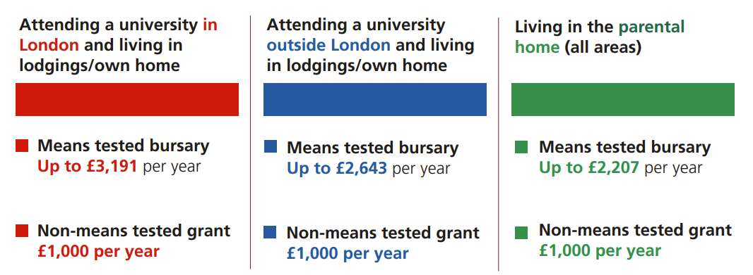
Fig 1: NHS Bursary Rates 2022/33. Taken from the NHS BSA guide to NHS Bursaries 2022/23, since replaced by The NHS Bursary Scheme New Rules Eleventh edition for the academic year 2022 to 2023, available at: https://assets.publishing.service.gov.uk/government/uploads/system/uploads/attachment_data/file/1101594/NHS_bursary_scheme_rules_11th_edition_academic_year_2022_to_2023.pdf
The above is a graphic representing the maintenance funding available to students in eligible years. The document this diagram was taken from has since been updated (see reference above). The old diagram has been used here simply because it’s clearer than the new one, but the numbers haven’t changed. The same applies to the graphic below.
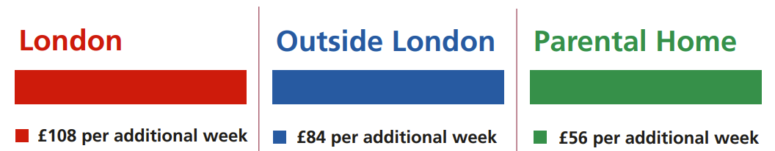
Fig 2: NHS Bursary Additional Weeks Allowance 2022/33. Taken from the NHS BSA guide to NHS Bursaries 2022/23, since replaced by The NHS Bursary Scheme New Rules Eleventh edition for the academic year 2022 to 2023, available at: https://assets.publishing.service.gov.uk/government/uploads/system/uploads/attachment_data/file/1101594/NHS_bursary_scheme_rules_11th_edition_academic_year_2022_to_2023.pdf

Summary
Multiple sources of finance are available to students embarking on their second degrees. The table below summarises the funding available to students from both Student Finance and the NHS bursary, based on the different course types.
Navigating the various applications isn’t easy, but taking the time to understand your situation and learn the options available to you is a very good place to start.
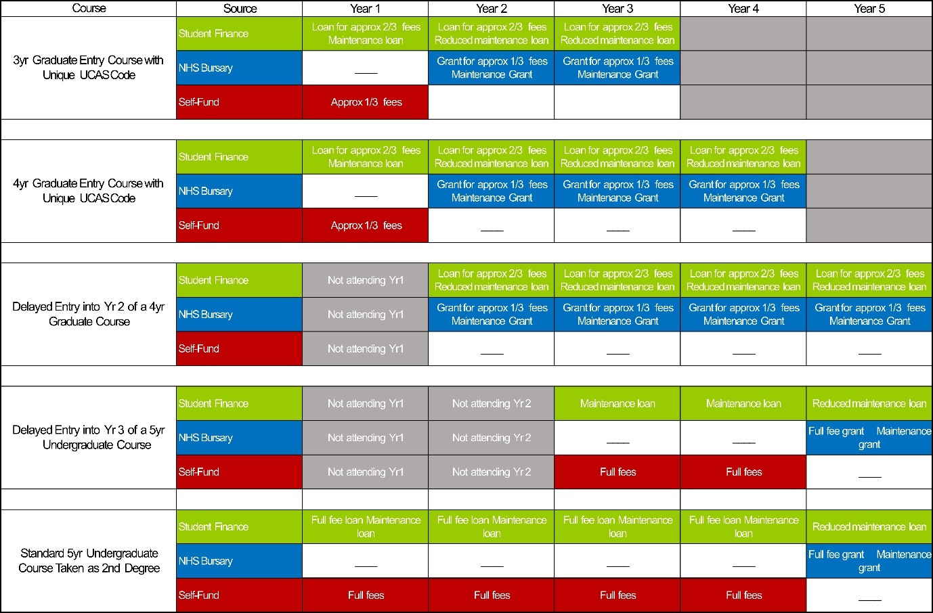

Disclaimer: This guide combines information from Student Finance and the NHS Business Service Authority with informal suggestions of ways to save money during a second degree. However, it should not be considered as formal financial advice, and the appropriate caution should be used when applying for any loans or other lines of credit.

