Audit of geographical differences in oral cancer patients in the North East of Scotland.

Samuel Kent*, Terry Lowe*.

*Department of Oral and Maxillofacial surgery, Aberdeen Royal Infirmary, Scotland.

Abstract

Introduction: Previous studies show that longer travel times and distances are associated with later disease stage at presentation and worse survival for a number of common cancers. The NE Scotland has both urban and rural populations, and a high incidence of H&N cancer. We asked whether increased travel time and distance was associated with more advanced disease on presentation, and worse one year survival. We discuss how this information should be considered in the context of designing future referral pathways
Methods: A retrospective audit of our head and neck cancer patients was carried out to determine whether there was a correlation between increasing travel times and stage of disease.
Results: 425 patients with head and neck cancer presented to our centre between May 2014 and May 2018. Unadjusted OR for nodal stage (N0 vs all other N stages) showed that nodal disease was increased (OR 2.00 CI 1.09-3.68) at 20-60 minutes travel time from hospital. One year all cause mortality followed the same trend, though was not statistically significant.
Discussion: The use of medical geographic information systems has improved understanding of disease in rural populations. Though our cohort is small, there are trends suggesting that H&N cancer patients who travel further for treatment are more likely to present with nodal disease, and have worse one year survival. Referral pathways which take these trends into account by may reduce the burden of late stage H&N cancer. We have applied for funding to study this effect on the entire Scottish population.

Introduction

Equality of access to treatment is a principle which underpins the National Health Service¹, and identification and reduction of health inequalities is a stated aim of the Scottish Government². Previous research at our centre has shown that rural patients with cancer have worse survival, despite shorter times from referral to initiation of treatment³. This paradox may be because rural patients present at a later stage in the disease process. Another study from our centre has shown that rural patients presenting for orthognathic surgery are more likely to require larger movements than those living close to the hospital⁴. Other studies of aggregate cancer types, have shown either no effect or worse outcomes in patients who travel farther for treatment, when correcting for age, sex and other demographic variables⁵⁻⁷.

From a health economics perspective, increased travel time is an additional cost to treatment⁸. Before bearing these costs, patients must have reason to believe that they will benefit from doing so. A likely cause of this willingness to bear additional costs may be increased awareness of symptoms. As head and neck cancers often present initially as a painless ulcer, rural patients, who have the additional travel costs to bear, may decide to present only when this ulcer takes on more concerning features such as pain, increased size, smell, or the presence of concurrent neck mass.

Aberdeen Royal Infirmary is a tertiary hospital which serves a large mixed population. Rural areas include the Islands of Orkney and Shetlland, some of the Scottish Highlands, Moray and Aberdeenshire, whilst Aberdeen city has an urban population of around 230,000⁹. Head and neck cancers are currently the 4th most common cancer in Scotland for men, and 8th for women, with a 5.2% increased incidence in Scotland between 2006 and 2016¹⁰. Therefore Aberdeen is an ideal setting in which to carry out this audit.

Since 2014, the North of Scotland Cancer network has collected a head and neck cancer dataset for Quality Performance Indicators (QPI)¹¹ to ensure that local practice meets agreed national standards. This dataset includes basic demographics, TNM staging¹², site, performance score, treatment aims and modalities, and date of death. Whilst the database only contains data since May 2014, it is well maintained, easily accessible and contains all of the information required to determine whether travel time from home to treatment centre correlates with disease severity at presentation.

This study aimed to determine whether stage of disease at presentation increase with increasing travel time to hospital?

Methods

Ethical approval was granted by the Caldicott Guardian at NHS Grampian, and the audit was registered internally with the same organisation.

Data was gathered from the local NHS Grampian QPI dataset¹¹. All cases of head and neck cancer which had been discussed at the multidisciplinary team meeting between May 2014 and May 2018 had been recorded. Data input had been carried out by the cancer audit team in NHS Grampian. This team use pathological data, imaging, scanned operation notes, and hospital mortality data to input cases. The database is maintained regularly, with date of death and treatment outcomes recorded when available.

Socioeconomic class was determined using the Scottish index of Multiple deprivations (SIMD) 2016 classification¹³. This classification system records 46 domains including car ownership, income, employment, education and A&E attendances to determine the socioeconomic class of each postcode area.

Distance from hospital and travel time was calculated using patient’s postcode at time of diagnosis. Travel times were by road, or by road and ferry from island communities.

Data was analysed using IBM SPSS (IBM Corp. Released 2017. IBM SPSS Statistics, Version 25.0. Armonk, NY: IBM Corp.). Differences between means in categorical data with normal distribution were checked using Independent Student’s T-test, and between categorical data using Chi square test. Further statistical analysis was carried out by the Institute of Applied Health Sciences in Aberdeen University.

Results

Four hundred and twenty four cases of head and neck cancer were recorded between May 2014 and May 2018. Most common site was oropharynx (n=137), followed by the oral cavity (n=127). Average age was 65.48 years, and 70% of the cohort was male. Two hundred and thirty eight (55.9%) of the cohort were active smokers at time of diagnosis (table 1.).

The cohort was divided into those living 30 minutes travel time or less from the treatment centre and those living greater than 30 minutes from the treatment centre. Results showed that only smoking status and SIMD varied significantly between the two groups. More non smokers and patients from less deprived areas were found to have a travel time of greater than 30 minutes form the hospital. (see table 1.)

Variable |  |  | Travel time |  | Significance
 |  | Entire cohort (n=424) | <30 mins (n=206) | >30 mins (n=218)
Age (years) mean, (SD) |  | 65.48 (11.9) | 65.1 (12.5) | 65.8 (11.3) | 0.615*
Sex (%) | Male | 297 (70) | 152 | 145
 | Female | 127 (30) | 54 | 73 | 0.11**
Smoking status (%) | Smoker | 186 (43.9) | 103 | 83
 | Non-smoker | 238 (55.9) | 103 | 135 | 0.013**
Site (%) | Oral cavity | 127 (29.8) | 57 | 70
 | Oropharynx | 137 (32.2) | 59 | 78
 | Salivary glands | 20 (4.7) | 8 | 12
 | Nasopharynx | 6 (1.4) | 3 | 3
 | Hypopharynx | 20 (4.7) | 12 | 8
 | Larynx | 87 (20.4) | 53 | 34
 | Other | 27 (6.4) | 14 | 13 | 0.282**
Nodal disease (%) | Positive | 181 (42.7) | 82 | 99
 | Negative | 177 (41.5) | 87 | 90
 | Not known | 66 (15.5) | 37 | 29 | 0.320**
TNM staging (%) | T1/T2 | 209 (49.3) | 98 | 111
 | T3/T4 | 138 (32.5) | 72 | 66
 | Unknown | 77 (18.2) | 36 | 41 | 0.785**
SIMD vintile | 1-11 (more deprived) | 189 | 65 | 124
 | 12-20 (less deprived) | 235 | 44 | 191 | 0.000**

- Cohort divided by travel time. All numbers are number of patients unless otherwise stated. *Independent student’s T-test **Chi square test.

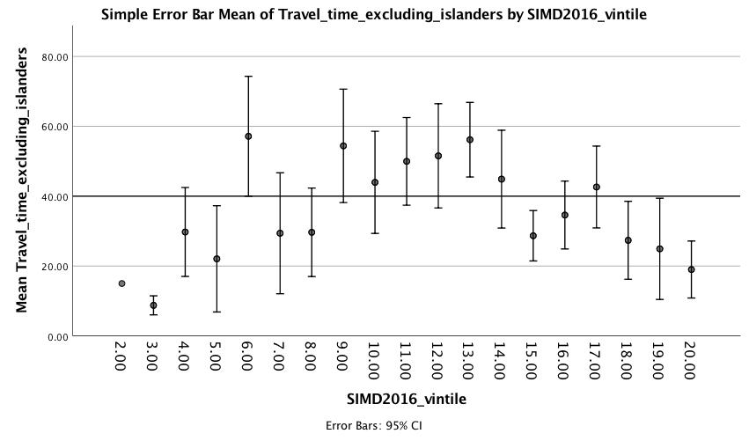
Figure 1. Mean travel time (minutes) from home to hospital, after excluding island communities.

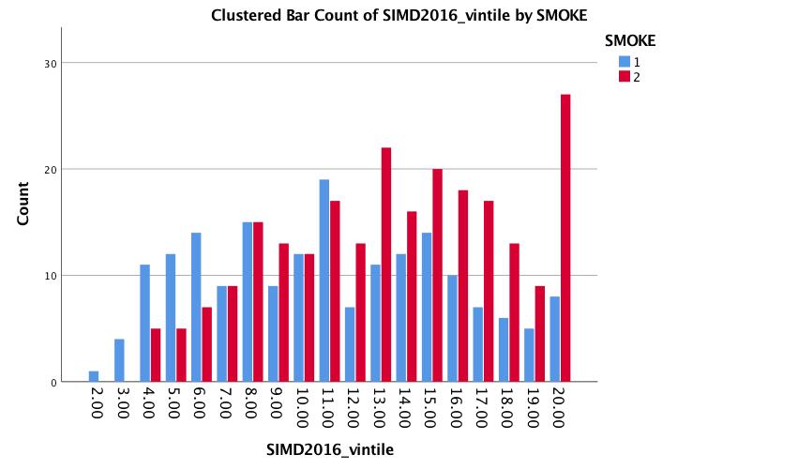
Further investigation was made of the differences between those from high and low SIMD, to determine whether SIMD was confounding the disease status at presentation (see table 2). Patients from the lowest and highest SIMD vintiles were found to live closest to the hospital, and this was true even after excluding island communities who tended to be in SIMD vintiles 5 to 15. Patients in the middle classes tend to live farthest from the hospital. Smoking status was another potential confounder, and figure two demonstrates the relationship between smoking status and SIMD, with patients from lower SIMD tending to be smokers whilst those from higher SIMD were more likely to be non smokers.

Figure 2. Smoking status (1=smoker 2=non smoker) arranged by Scottish Index of Multiple Deprivations (SIMD) vintile.

 |  | SIMD Quintiles 1-11 (n=189) | SIMD Quintiles 12-20 (n=235)
Mean age (years)(SD) |  | 64.96 (10.74) | 65.92 (12.83) | 0.450*
Sex | Male | 134 | 163
 | Female | 55 | 72 | 0.407**
Smoking status | Smoker | 106 | 80
 | Non-smoker | 83 | 155 | 0.000**
Site | Oral cavity | 46 | 81
 | Oropharynx | 56 | 81
 | Salivary glands | 9 | 11
 | Nasopharynx | 3 | 3
 | Hypopharynx | 10 | 10
 | Larynx | 53 | 34
 | Other | 11 | 14 | 0.056**
Nodal disease | Positive | 72 | 105
 | Negative | 83 | 98
 | Not known | 34 | 32 | 0.126**
TNM staging | T1/T2 | 87 | 122
 | T3/T4 | 69 | 69
 | Unknown | 33 | 44 | 0.292**
Travel time | 0-30 minutes | 65 | 44
 | >30 minutes | 124 | 191 | 0.000**

Table 2. Cohort divided by SIMD. All numbers are number of patients unless otherwise stated. *Independent student’s T-test **Chi square test.

Further analysis of the cohort was carried out by a statistician (see acknowledgments), who used unadjusted odds ratios to show that at 20-60 minutes travel time from hospital compared to 0-20 minutes from hospital, chances of nodal disease were increased (OR 2.00 CI 1.09-3.68). Odds ratios of all cause mortality within one year of diagnosis followed the same trend, though was not statistically significant.

Conclusions.

We have carried out an audit of head and neck cancer patients presenting to our centre, to determine whether higher stage at presentation is seen with increasing travel times. Our results highlight the complexity of the relationship between travel distance and stage at presentations. Socioeconomic class and smoking status may be confounding our results, making the relationship more complex.
Distance from hospital varied with socioeconomic class, with patients from the lower socioeconomic classes living closer to the hospital. However, the relationship is more complex, as seen in Figure 1. Patients from the highest and lowest SIMD vintiles lived closest to the hospital, whilst the middle SIMD classes lived farther from the hospital. Island communities had to be excluded because they are exclusively from vintiles 7 to 14, however the relationship remains. Therefore any difference in nodal status or tutor size with travel time may be masked by socioeconomic class.

Smoking status also varied by both SIMD and by distance from hospital. As expected, patients from low socioeconomic classes were more likely to be active smokers at the time of diagnosis, whilst those from higher classes were more likely be non smokers. However, smoking status also varies by distance from hospital, with patients living closer to the hospital being more likely to smoke (see table 1). Therefore any difference in nodal status or tutor size with distance from hospital may again be confounded by smoking status.

The complexity of this relationship required specialist input, and the authors were greatly assisted by the involvement of the Insitute of Applied Health Sciences in Aberdeen Univeristy. Using an alternative analysis, which involved splitting the cohort into three groups of travel times (0-20 minutes, 20-60 minutes and >60 minutes), the statistician was able to show that odds of nodal disease, and also of all cause mortality at one year increased with increasing distance from treatment centre.

However, it was noted that the cohort was small (previous studies into this subject have used cohorts of over 10,000 patients). A power calculation was carried out which suggested that sample sizes of 1486 in each group was required to show a difference in tumour size between those travelling 0-20 vs 20-60 minutes. To achieve an adequate sample size this audit would have to be carried out nationally. Therefore an application has been made to the NHS Endowments scheme in NHS Grampian for funding to audit centrally held records. The outcomes of this national audit will be analysed using multiple logistic regression. Confounders (for example age, sex) will be assessed for using appropriate statistical tests.

These results of this national audit will be of particular importance for two reasons. Firstly, head and neck cancer services in the north of Scotland are currently being rationalised with some head and neck cancer patients being referred to either Glasgow, Aberdeen or Dundee. Understanding the healthcare implications of increasing travel time to hospital is important to allow accurate determination of the effects of these changes. Secondly, one of the drivers of the paradox of worse survival despite shorter waiting times experienced by Scottish cancer patients may be due to higher stage at presentation. Our study will determine if this is the case, strengthening the need for strategies to minimise the healthcare disadvantages experienced by rural populations in Scotland.

Acknowledgments

The authors gratefully acknowledge the assistance of Melanie Turner of the Insitute of Applied Health Sciences at Aberdeen University.

References

- Equality, diversity and health inequalities. About NHS England. Accessed on 27/1/2019 at https://www.england.nhs.uk/about/equality/

- We have tackled the significant inequalities in Scottish society. Scottish Government. 2017. Accessed on 27/1/2019 at https://www2.gov.scot/About/Performance/scotPerforms/outcome/inequalities

- Turner M, Fielding S, Ong Y, et al. A cancer geography paradox? Poorer cancer outcomes with longer travelling times to healthcare facilities despite prompter diagnosis and treatment: a data-linkage study. Br J Cancer. 2017;117(3):439-449.

- Kent SJW, Morrison RMW. Rural and urban differences in orthognathic surgical patients in the north east of Scotland. Br J Oral Maxillofac Surg. 2018 Dec;56(10):931-932.

- Murage P, Murchie P, Bachmann M, Crawford M, Jones A. Impact of travel time and rurality on presentation and outcomes of symptomatic colorectal cancer: a cross-sectional cohort study in primary care. Br J Gen Pract. 2017;67(660):e460-e466.

- Liang M, Yang J, Deng G. Mapping rural–urban disparities in late-stage cancer with high resolution rurality index and GWR. Spatial and patio-temporal epidemiology. 2018;26:15-23.

- Baade PD, Dasgupta P, Aitken J, Turrell G. Geographic remoteness and risk of advanced colorectal cancer at diagnosis in Queensland: a multilevel study. Br J Cancer. 2011;105(7): 1039-41.

- Spatial Economics: The Declining Cost of Distance. Bain and Company. 2016. Accesssed on 27/1/2019 at https://www.bain.com/insights/spatial-economics-the-declining-cost-of-distance/

- Aberdeen Population 2019. World Population Review. Accessed on 27/1/2019 at http://worldpopulationreview.com/world-cities/aberdeen-population/

- Head and Neck cancer statistics. ISD Scotland. 2018. Accessed on 27/1/2019 at https://www.isdscotland.org/Health-Topics/Cancer/Cancer-Statistics/Head-and-Neck/#summary

- Quality Improvement indicators. North region health and care collaboration. 2018.Accessed on 27/1/2019 at https://www.nrhcc.scot/nca

- TNM Classification of Malignant Tumours - 7 th ed.Union for International Cancer control. December 2009. Accessed on 27/1/2019 at https://www.uicc.org/sites/main/files/private/TNM_Classification_of_Malignant_Tumours_Website_15%20MAy2011.pdf

- The Scottish Index of Multiple Deprivation. Scottish Government. August 2016. Accessed on 27/1/2019 at https://www2.gov.scot/Topics/Statistics/SIMD.

