Data Entry in Redcap
COVID OMFS Trauma and Infection Audits

Introduction
REDCap is a versatile system for recording data including, in some cases, patient identifiable data. As well as its versatility, it has the advantage for medical researchers that it is very economical to use.
Its disadvantages are few but important to understand.
Firstly, because it can be used for patient identifiable data, registering to use REDCap for the first time requires a little more security than other systems such as SurveyMonkey or WuFoo. You need to apply for a user name and initial password, which you can then change to one of your own. Fortunately our Quality Outcomes in oral and Maxillofacial Surgery (QOMS) lead Fabien Puglia is available to help you every step of the way.
Secondly, the initial user interface appears complex and unfriendly when you see it for the first time. First time users should follow the screen shots and step by step instructions. Once you have used REDCap a few times, it will become second nature.
Finally, any database in which patient identifiable data (NHS number, name/DoB) is not recorded will require the user to keep a secondary record of the REDCap ID number. This record should be stored securely following your local Caldicott Guardian’s advice.
You have completed your registration with QMUL (i.e. changed your password). Now what?

1. Log in to REDCap
Go to: https://trials.nforc.co.uk/ and log in with your username and password.
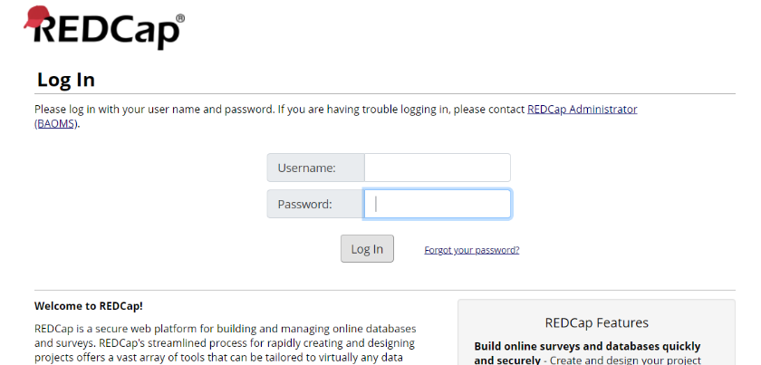

2. Navigate in REDCap
2.1 | Go to “My Projects” in the top menu bar.
2.2 | You will see the list of projects you have access to, amongst them, you should find the “Covid-19 OMFS trauma” and “Covid-19 dental infection” audits. Click on one of them.
 | 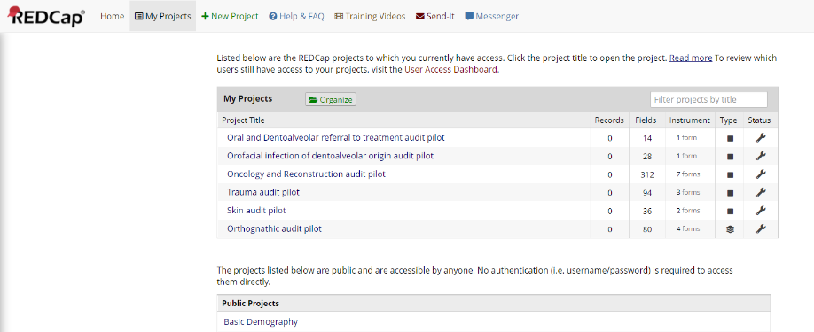
2.3 | On the project home page, click on Add / Edit Record on the left panel
 | 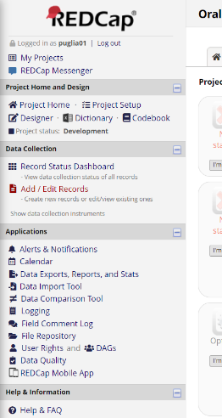
2.4 | To create a new record:  - Click on Add new record
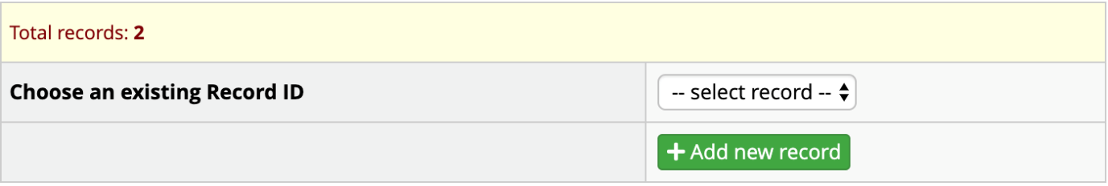
1
 | - If you have selected Dental infection, you will be taken directly to the questionnaire and you can start completing it
 | - If you have selected OMFS trauma, you will taken to the Record home page, click on the grey circle below “Baseline”
 | 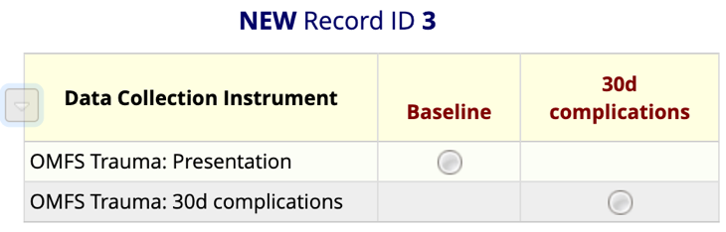
2.5 | Similarly, to edit a record, simply go to ‘Select record’
2.6 | To Save data: at the end and on the side of each questionnaire you will find a ‘Saving menu’. Select the option yo uneed and click on it.
 | 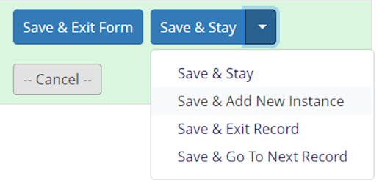

for any query or problem
You can contact:
QOMS non-clinical lead: | Fabien Puglia  E: qoms@baoms.org.uk  T: 020 7251 9060
NFORC Team: | E: info@nforc.co.uk  T: 020 8223 8049
BCC Helpdesk | E: bcc-webhelpdesk@qmul.ac.uk  (provide your username and registered email address to speed up the process)
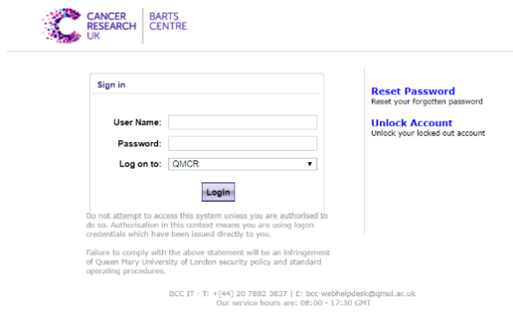
In case you forget your password or lock yourself out of your account, go to https://selfservice.bcc.qmul.ac.uk/ and use the links on the right ‘Reset Password’ and ‘Unlock Account’

