



Application Form

The North East Microsurgery Training Course Workshop

21-22 March 2019



**Newcastle Surgical Training Centre** delivers over 150 advanced training courses from regional, national and international surgeons representing multi specialties. Collaboration with national and international faculty drives a greater understanding of surgical techniques delivering improved patient care.

**www.nstcsurg.org**

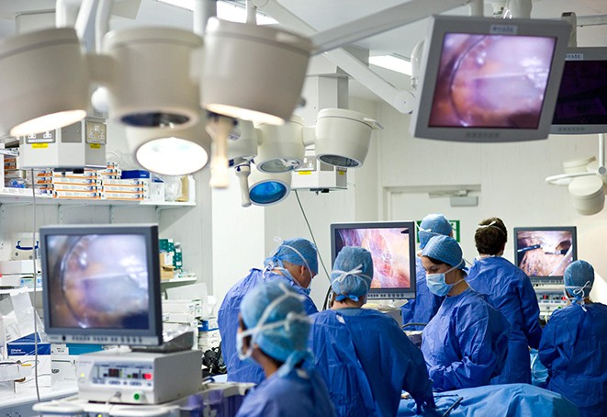

**FACULTY**

Mr Mani Ragbir – Newcastle upon Tyne Hospitals, Consultant Plastic Surgeon

Mr. James Wokes - Newcastle upon Tyne Hospitals, Specialty Training Doctor

Further Faculty to be confirmed

Further information

For full details and registration information visit www.nstcsurg.org

Or contact: Louise Sore

Freeman Hospital, Newcastle upon Tyne

Tel: (+44) 191 213 8589

Email: louise.sore@nuth.nhs.uk

**www.nstcsurg.org**

**Newcastle Surgical Training Centre**

At the Newcastle Surgical Training Centre we are committed to giving you the best possible opportunities in education and training by offering a wide range of multidisciplinary courses to meet your every need. Our highly professional clinicians are here to train and support you every step of the way. Combining didactic teaching and practical procedures with leading edge technology, we offer first rate cadaveric training and continuing professional development in a purpose built facility. We also carry out pioneering research into new techniques and ensuring that you receive the very best surgical training available in the UK, both for today and in the future.

The Newcastle Surgical Training Centre is led by the co-directorship of Professor Alan Horgan and Professor David Deehan. The centre delivers over 150 advanced training courses from regional, national and international surgeons representing multi specialties. Collaboration with national and international faculty drives a greater understanding of surgical techniques delivering improved patient care.

About the centre

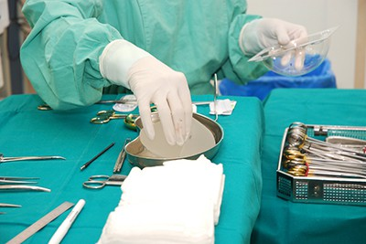

Course overview

This course is designed for core surgical trainees in Plastic

Surgery, Otolaryngology and Maxillofacial Surgery who

have little or no experience in microsurgery or a refresher

course for senior trainees

The course is designed for surgical trainees in Plastic

Surgery, Otolaryngology, Maxillofacial Surgery, to attain

practical skills in Microvascular Surgery and has been

structured to gain maximum hands-on experience under

the supervision of experienced faculty. Each participant

will have a separate table equipped with operating

microscope, micro instruments and sutures.

At the end of the course trainees will be able to know and

handle microsurgical instruments

TOPICS COVERED

* Microsurgery equipment
* Basics of Microsurgery techniques

**Nerve Coaptation**

* Primary Nerve Repair
* Interpositional Nerve Graft

**Vessel Anastomosis**

* End to End
* End to side
* Interpositional vein graft

Special features of the course

* Intensive two-day hands on practical experience using microscopes, avian tissue and simulators to practice vessels anastomosis
* Faculty: Delegate ratio of 1:2 delivered by consultants and Senior SpRs in Plastic Surgery
* Consultant delivered lectures covering basic principles, pearls and pitfalls of microsurgery
* All refreshments included

Course certificate

**TARGET AUDIENCE**

**CT2- ST4**

**www.nstcsurg.org**

**Newcastle Surgical Training Centre**

Application Form

Course title:

The North East Microsurgery Training Course Workshop

Date:

21-22 March 2019

|  |  |  |  |
| --- | --- | --- | --- |
|  | | | |
| Course fee | £600 |  |  |
|  |  |  |  |
|  |  |  |  |

|  |  |
| --- | --- |
| Your details | |
| Surname: | Title: (Mr / Mrs / Miss / Ms ) |
| Forenames: | |
| Job Title: | Department: |
| Hospital Address: |  |
|  | Postcode: |
| Mobile Telephone: | Email: |

|  |
| --- |
| Further details |
| How did you hear about this course? Trust Website Mailing Other |
|  |
| Please state any special dietary requirements: |
|  |
|  |
|  |
| Please state to whom invoices should be addressed, if no alternative contact is given, all invoices  will be directed to the applicant |

|  |  |
| --- | --- |
| Declaration | |
| Signed: | Date: |

     

     

     

     

**Please note:** The course fee will include: lunch and refreshments. Payment can be made via BACS (automatic bank transfer)

by Credit Card, or by cheque payable to **Newcastle upon Tyne Hospitals NHS Trust.** Full details and registration information at www.nstcsurg.org Please note payment is due at registration to secure your place. Attendance on the course is conditional upon advance payment being received. Refunds cannot be given in the event of your cancellation within two weeks of the course date. The NSTC cannot accept liability for costs incurred in the event of a course having to be cancelled as a result of circumstances beyond its reasonable control. There is an administration charge of 10% (or £50, whichever is greater) of the total course fee. However, within four weeks prior to the start date of the course, the total course fee will be charged unless in exceptional circumstances at the discretion of the NSTC.

While we make every effort to run courses as advertised, we reserve the right to change the timetable and/or the teaching staff without prior notice and to cancel any courses without liability (in which case there will be a full refund of course fees to participant). Note that any consequential losses (e.g. travel or accommodation costs) incurred in such cases remain the responsibility of the booker, and consideration should be made to taking out appropriate travel insurance for any non-refundable costs.

     

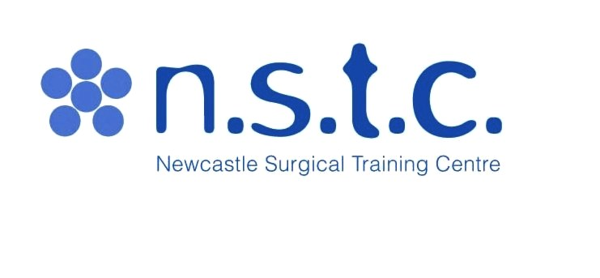 **Newcastle Surgical Training Centre**

**On line Credit Card Payment Authorization Form**

Sign and complete this form to authorize **Newcastle Surgical Training Centre** to make a one time debit to your credit card listed below. By signing this form you give us permission to debit your account for the amount indicated on or after the indicated date. This is permission for a single transaction only, and does not provide authorization for any additional unrelated debits or credits to your account.

**Please complete the information below:**

Please state Name: I ……………………………………………………………………… authorize Newcastle Surgical Training Centre to charge my credit card   
  
Microsurgery Course £600

**Address including Postcode:**

|  |  |
| --- | --- |
|  |  |
|  |  |
|  |  |
|  |  |
|  |  |
|  |  |

|  |  |
| --- | --- |
| **Email:** |  |
| **Phone:** |  |

|  |  |  |  |  |  |  |  |  |  |  |
| --- | --- | --- | --- | --- | --- | --- | --- | --- | --- | --- |
| Account Type:  Visa  MasterCard  Discover **WE DO NOT ACCEPT DINERS CLUB OR AMEX**   |  |  | | --- | --- | | **Cardholder Name** |  | | **CARD Number** | ______________________________________________________________________ | | **Expiration Date** | _____________________________________________________________________ | | **Valid from date**  **Security number(3 digit number on back of Visa/MasterCard** | ____________________________________________________________________  ­­­­­­­­­­­­­­­­­­­_____________________________________________________________________  ­­­­­­­­­­­­­­­­­­­­­­­­­­­­­­­ | |  |  | |

**SIGNATURE:** **DATE:**

I authorize the above named business to charge the credit card indicated in this authorization form according to the terms outlined above. This payment authorization is for the goods/services described above, for the amount indicated above only, and is valid for one time use only. I certify that I am an authorized user of this credit card and that I will not dispute the payment with my credit card company; so long as the transaction corresponds to the terms indicated in this form.

**Newcastle Surgical Training Centre, Freeman Hospital, High Heaton, Newcastle upon Tyne. NE7 7DN**

**Tel 0191 24 48913 Email:** [**Lorraine.waugh@nuth.nhs.uk**](mailto:Lorraine.waugh@nuth.nhs.uk)

|  |  |
| --- | --- |
| **https://webmail.nuth.nhs.uk/WebMail/Lorraine.Waugh/Inbox/NSTC%20logo%20and%20spotlights.EML/1_multipart_xF8FF_3_multipart_xF8FF_1_n.s.t.c._logo.jpg/C58EA28C-18C0-4a97-9AF2-036E93DDAFB3/n.s.t.c._logo.jpg?attach=1**  **BACS DETAILS**  Newcastle Upon Tyne Hospitals NHS Trust  Bank Details for Transfer of Money. | |
| **Bank Name** | **HSBC Bank** |
| **Bank Address:** | **110 Grey Street**  **Newcastle upon Tyne**  **NE1 6JG** |
| **Sort Code:** | **40-34-18** |
| **Account No.:** | **41763709** |
| **Account Name:** | **NUTH No.1 account** |
| **IBAN No.:** | **GB26HBUK40341841763709** |
| **BIC code** | **(BIC11):HBUKGB4108J** |
| **VAT No:** | **654 9687 77** |
| **Reference:** | **SURGTRAINING** |