Wednesday, 7 December 2016

Charity Today News

Family returns to volunteer on floating hospital in West Africa
06/12/2016
SHARE
Opting for a rather different family holiday in the new year, a London-based family will travel to Benin to spend two weeks volunteering on board the world’s largest floating hospital.
Marking International Volunteers Day today (5th December), Dr. Leo Cheng, his wife, Hilary Cheng, and their two daughters, Kat and Zoe Cheng, who reside in Chingford, have announced that they will return to the floating hospital, the Africa Mercy, which is currently docked in Benin.
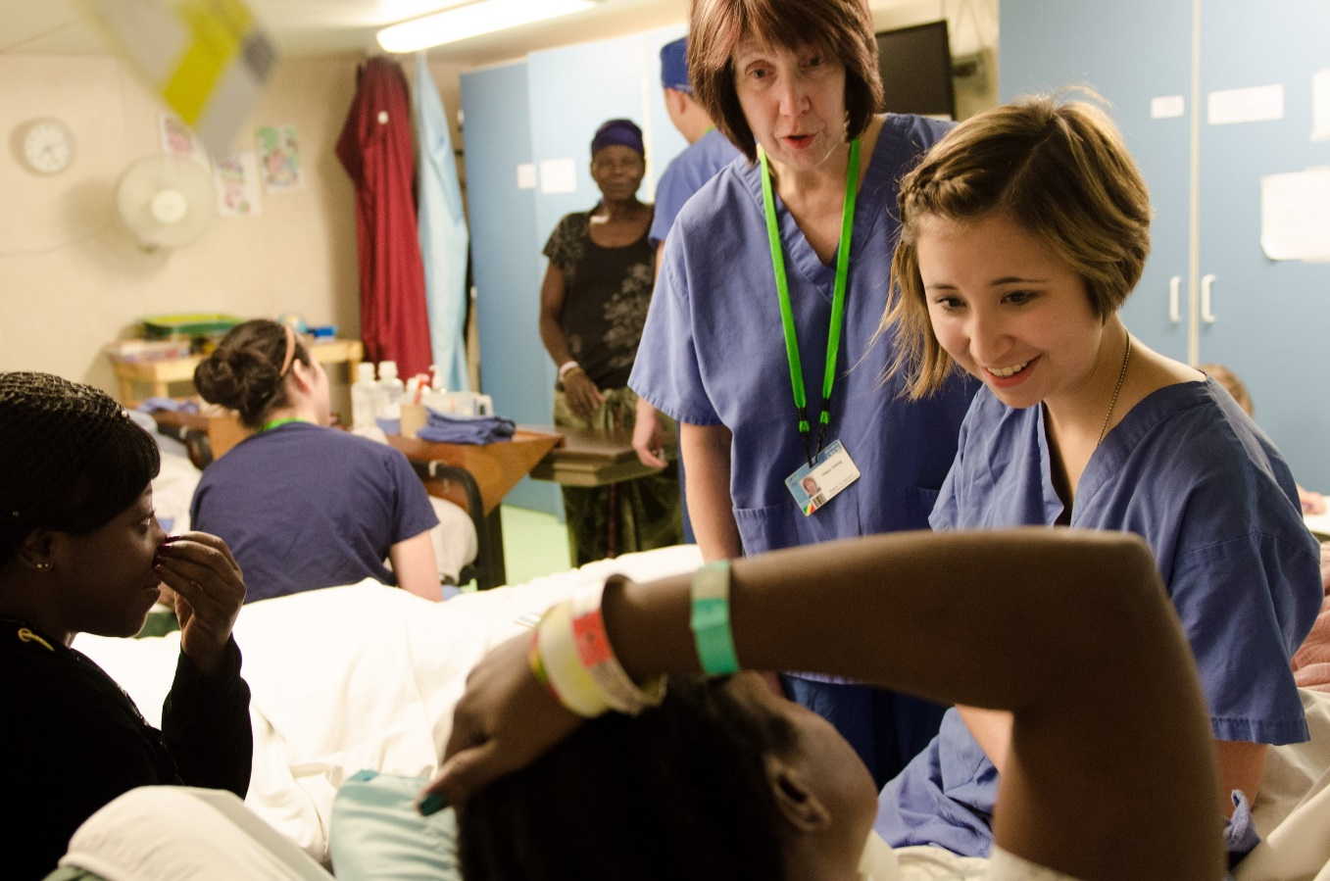Photo Credit: Michelle Murrey
It will be the 14th visit to the Africa Mercy for Dr. Cheng, a Consultant Oral, Maxillofacial, Head and Neck Surgeon at St Bartholomew’s, The Royal London and Homerton Hospitals; however it will be the 2nd time the Cheng’s have volunteered for Mercy Ships as a family.
Mercy Ships docks in some of the poorest countries in Africa to offer free healthcare and humanitarian aid. Since the charity’s creation in 1978, Mercy Ships has transformed the lives of more than 2.56 million people.
While volunteering on the ship, Dr. Cheng will perform 2 or 3 surgeries a day, often on patients who have never received any kind of healthcare. His patients are children and adults suffering from enlarged thyroid, head and neck tumours, and serious wounds.
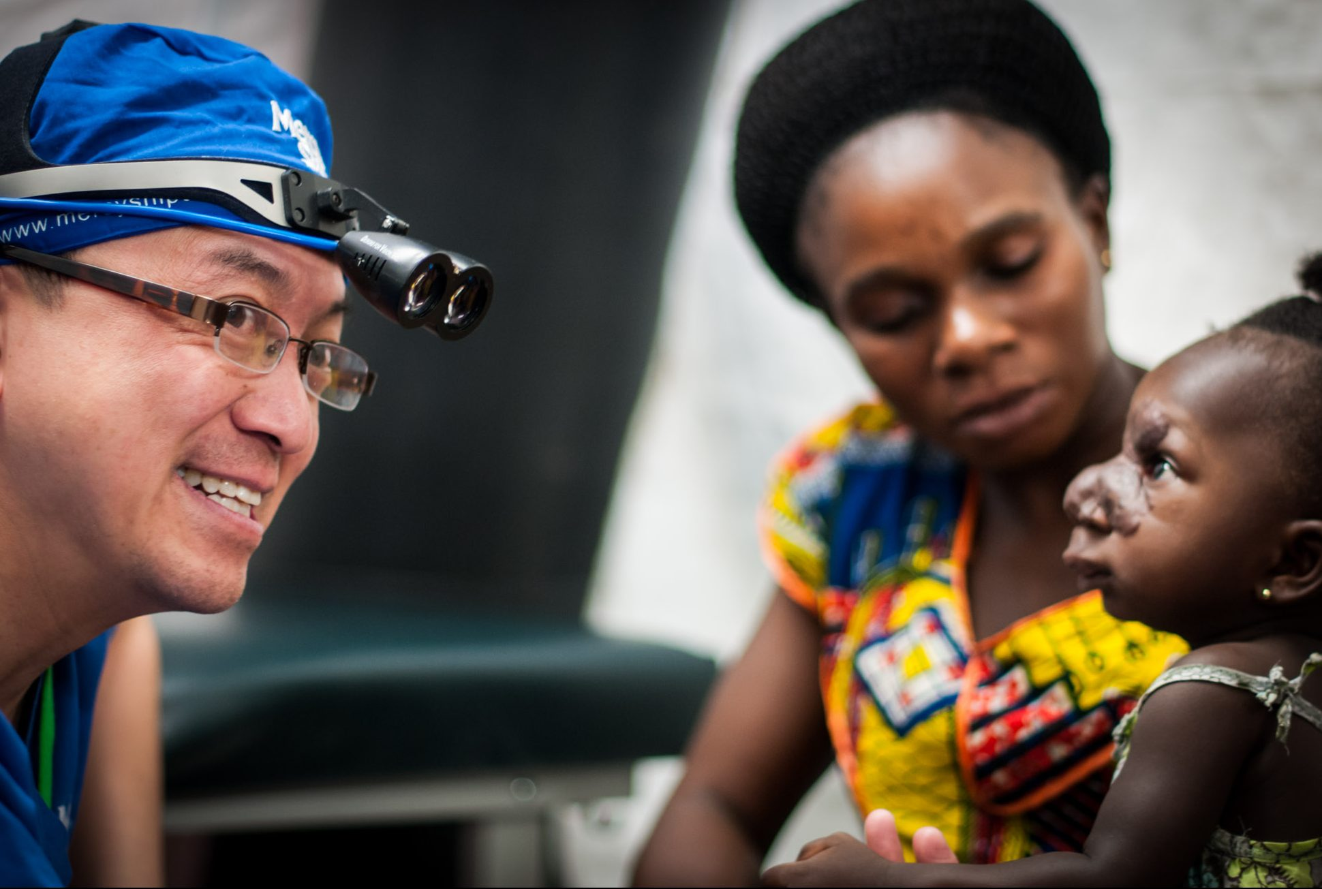Dr. Leo CHENG (GBR) during screening, on the dock. Photo Credit Ruben Plomp
Hilary will be serving as a Chaplain for the patients on board, supporting them through their life-changing journeys and providing them with spiritual guidance. Kat will be serving as a nurse and Zoe in hospitality.
Every Mercy Ships volunteer pays to be on the ship, meaning that the Cheng’s are financing their own travel and accommodation, and all other expenses involved in spending time on board. As a result of Mercy Ships’ unique business model, all donations made to the charity go straight to patient care and maintaining the hospital ship.
Dr. Cheng said: “It is such a privilege to serve on the Africa Mercy with my family again. When we deliver hope and healing to those desperate patients and their loved ones, we also receive far more through the grace, patience and gratitude from those we serve.
“Our culture tells us to acquire more and more for personal gain, but on the Africa Mercy, the volunteers find purpose in their lives by serving others.”
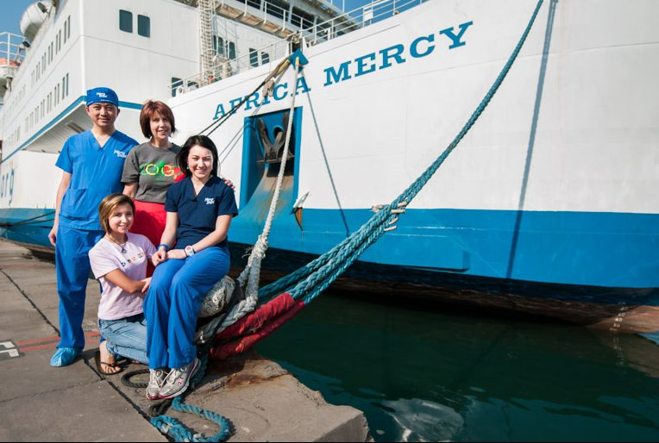Photo Credit Ruben Plomp
Dr Cheng’s daughter, Kat, added: “Returning to the Africa Mercy is like going to my second home. Now I am further on in my nursing career; I have a greater understanding and appreciation for the life-changing care that is delivered by each and every volunteer on board, and I strive to make a positive difference to the lives of those I meet in Benin.”
Lea Milligan, Executive Director for Mercy Ships UK, said: “We are very happy to welcome back the Cheng family, who not only regularly volunteer on our hospital ship, but also dedicate so much of their time throughout the year to support our charitable efforts. Our volunteers really are the heart of the ship – they are the ones that truly make a difference to the people of West Africa.”
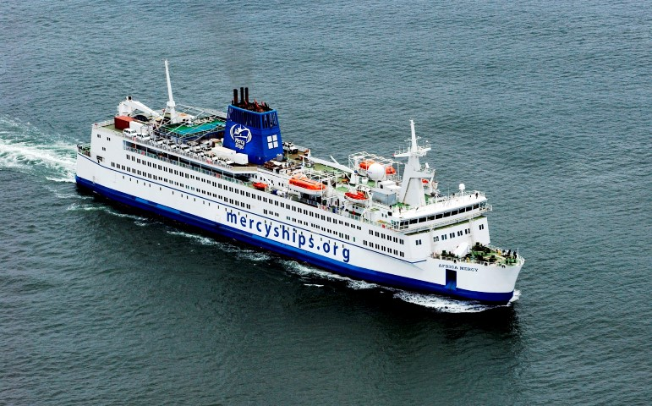
With a crew of over 400 professional volunteers from more than 40 nations, many of whom are from the UK, Mercy Ships volunteers will deliver and support the provision of free medical services to Benin’s population of 10 million, in addition to carrying out mentoring and training programmes.

