The OMFS MRCS Revision Series – An Overview of Progress
BAOMS Student Bursary Project 2022
Danielle Britton

The Teaching Programme

For the 2022 BAOMS student bursary project, I set out to design, develop and run an online webinar-based revision series for the MRCS examination for OMFS trainees. The programme consisted of weekly revision sessions on key exam topics (see example timetable below).

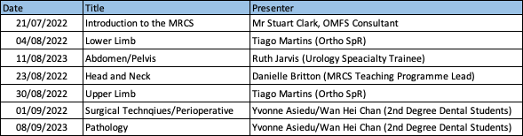

Each weekly session focused upon one aspect of the MRCS Part A syllabus deemed of high importance by trainees in a pre-programme questionnaire – covering mainly anatomy, but also pathology and surgical perioperative care. Each webinar ran for roughly 60 minutes, in the form of case-based discussions with SBA style questions and summaries of key points for each topic.

Feedback

Because the first round of the revision series, leading up to the September 2022 MRCS Part A examination, was well attended and very highly rated by trainees, I ran this programme two further times, on the run up to MRCS Part A examinations in January and May 2023. As can be seen below, each session was highly rated with participants feeling more confident on topics in every teaching session given over the year, with confidence increasing between 20-30%.

Conclusion
Overall, the revision series was a success when assessing individual session feedback. Attempts were made to get more concrete data on exam performance from those attending the course, but engagement in follow up questionnaires was poor. Based on feedback gathering during sessions, the main issue with the series itself was the ‘fixed’ online timetabling as sessions ran live, which is an aspect I am planning to revisit over the coming year to allow equal access and opportunity to MRCS revision resources.

Further Comments From Attendees

