Key e-Courses for ST OMFS (and where to find them)
You may already be aware of the area about eFace on the BAOMS website which has key resources for DCTs and Specialty Trainees.
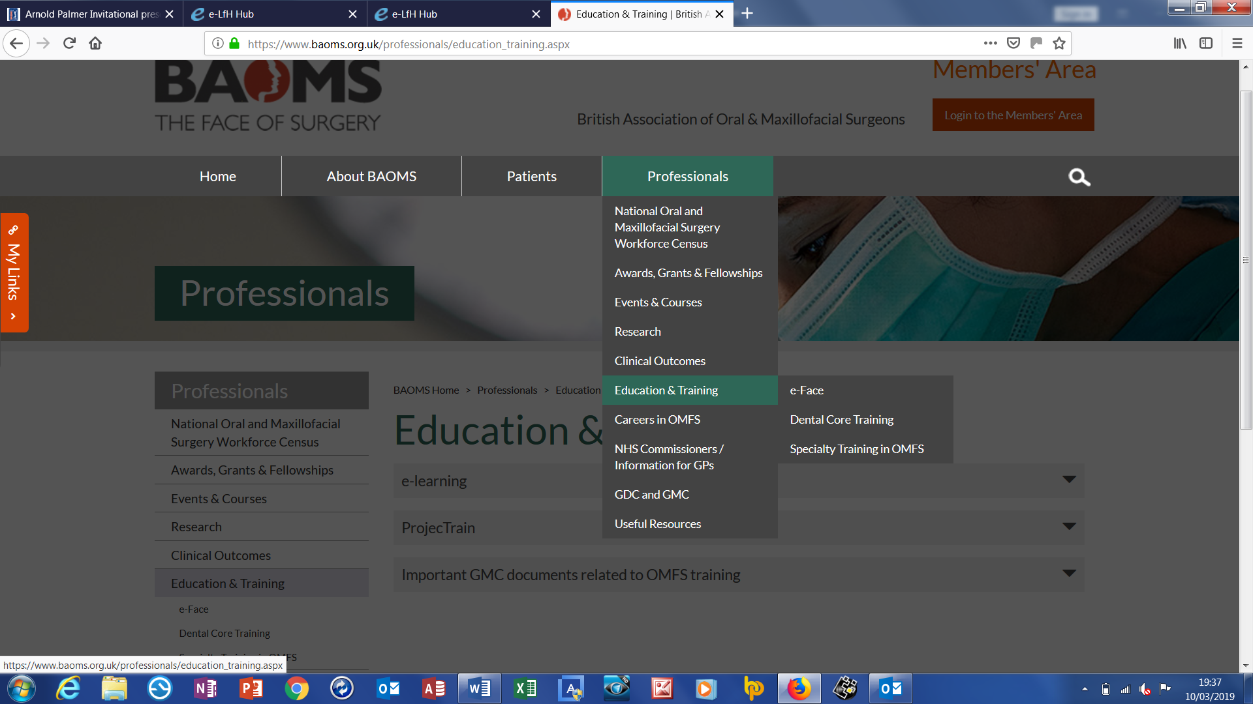

Key Courses for ST trainees (and where to find them) 1
Register for Free Online Resources 2
National Institute for Health Research (NIHR) 2
e-Learning For Health (eLfH) 2
Research and Audit Essentials 2
Good Clinical Practice (GCP) 2
Granule 2
Research and Audit on E-Learning for Health (eLfH) 2
Audit Essentials 2
Module 1 Research and Audit Core Knowledge 2
Module 2 Perioperative Improvement Science and Management (PRISM-ed) 2
Surgery (OS and OMFS) essentials on eLfH – eFace 2
Medical Skills in OMFS 3
Oral surgery and the principles of care of the elective surgical patient 3
Facial pain 3
Essentials of good oral and maxillofacial surgery practice 3
Other OMFS modules 3

Register for Free Online Resources

National Institute for Health Research (NIHR)
Provide this online charge free of charge. It does require a little time to register but there is no charge. An NHS e-mail is needed.
https://learn.nihr.ac.uk/enrol/

e-Learning For Health (eLfH)
https://www.e-lfh.org.uk/
There is lots of useful material on the eLfH website and this includes a series of modules which have been assembled to address the requirements for doctors and dentists.
eLfH, like NIHR needs an NHS e-mail but is free to use.

Research and Audit Essentials – Needed for CCT checklist

Good Clinical Practice (GCP)
GCP Is a requirement for OMFS STs at CCT. It is also , but is a valuable course for all of those who might be dealing with patients who are part of a clinical research programme. It will take 4 or so hours to complete.

Granule
https://learn.nihr.ac.uk/enrol/index.php?id=385
‘Granule’ is another course which sits alongside GCP. It is also on the NIHR website. It is targeted at students or anyone new to research. It consists of a series of videos with some interactive questions. about 90 minutes work

Research and Audit on E-Learning for Health (eLfH)
e-Face 16_08 – Research
There are a full set of modules which, if completed, will tick the needed box for ‘research methodology’ requirement at OMFS CCT. Complete all the modules to generate your certificate. Approximately 8 hours work.

Audit Essentials – Useful Resources

Module 1 Research and Audit Core Knowledge
There is an overlap between research and audit in principle and also on eLfH. This module is a series of courses which cover a lot of areas.

Module 2 Perioperative Improvement Science and Management (PRISM-ed)
Focussed on audit, but also includes human factors.

OMFS ‘essentials’ on eLfH – eFace
e-Face is an online resource within e-lfh with lots of OMFS material which is aimed at DCTs working in OMFS and new STs in OMFS. It also includes modules on generic professional skills.
It was put together some years ago by Carrie Newlands and Daljit Dhariwal and kept up to date for BAOMS by Jason Green.

Medical Skills in OMFS
Is a good package to recommend to new STs but especially for your DCTs. Worth being familiar with so you can direct and support your DCTs or introduce CTs to the specialty. It includes managing the unwell patient.

Oral surgery and the principles of care of the elective surgical patient
Includes Radiology in oral surgery, Pre and post-operative care in oral surgery and Assessment of the dental patient

Facial pain
Covers facial and dental pain.

Essentials of good oral and maxillofacial surgery practice
Includes, ethics and professionalism

Other OMFS modules
Craniofacial trauma, Head and neck oncology, Salivary glands, Facial deformity, Head and neck infections, Surgical dermatology and Craniofacial surgery

