e-Learning for Healthcare - A new process of consent for OMFS Trauma

Introduction

The General Medical Council outline seven principles of decision making and consent.⁽¹⁾ Oral and Maxillofacial Surgeons have an ethical and legal obligation to adhere to these principles as part of their duty of care to patients. Understanding the values of consent is fundamental for every clinician independent of experience.

Following the historic Montgomery vs Lanarkshire case in 2015, the existing informed consent process was remodelled. The RCSEng Consent: Supported Decision-Making document clearly outlines the new legislation pertinent to the consent process which applies to all medical and surgical specialties.

The guidance states that “The surgeon discussing treatment with the patient should be suitably trained and qualified to provide the treatment in question and have sufficient knowledge of the associated risks and complications, as well as any alternative treatments available for the patient’s condition.”⁽²⁾

The practicality of this can often be a challenge within a busy OMFS unit and therefore the consent process may be delegated to a junior member of the team. The legislation acknowledges this problem and advises that if the responsible surgeon is unable to complete the consent process then a suitably trained alternative is appropriate.

The experience of OMFS junior trainees can vary greatly in relation to their understanding of surgical procedures, alternatives and potential complications. At present, there is no formal standardised training method for consent for junior trainees.

The main objective of this project was to develop a set of e-Learning for Healthcare (e-LfH) modules focusing on consent for key trauma procedures commonly performed by Oral and Maxillofacial Surgery.

Under the guidance and supervision of Mr Laurence Newman, OMFS Consultant and the team at e-LfH we aimed to create an interactive platform to assist participants gain the necessary knowledge required to perform delegated consent in each of the proposed procedures.

Methods

The procedures listed below were identified as common OMFS trauma operations and formed the basis for six e-LfH modules:

- Management of an Uncomplicated Fractured Mandible
- Management of an Uncomplicated Fractured Zygoma
- Management of a Mandibular Condyle Fracture
- Management of Mid-Facial Fractures
- Management of an Uncomplicated Facial Soft Tissue Wound
- Management of Dental Injuries and Dentoalveloar Fractures

A project plan and timeline was formulated following a virtual team meeting. Subsequently, e-LfH provided a template and session outline which was used to create each module (Appendix 1). The layout of each session was standardised with learning objectives, an introduction, case study and summary. The case study comprised of a trauma history, discussion regarding need for treatment, alternatives, risks and finally reasoning why informed consent is required. Each module also contained an interactive questioning section. The team reviewed each session and amendments were completed before finalisation (Appendix 2).

Results

Six online consent sessions focusing on OMFS trauma operations were created and published on the e-LfH website (Appendix 3). Each session was based on the most up to date consent information at the time of publication.

Conclusion

It is hoped that these online modules will help assist junior trainees develop the knowledge and skills required to perform delegated consent for a range of OMFS procedures. The online platform could be implemented within junior trainee induction programmes in OMFS departments in the future.

Acknowledgments

Many thanks to the following people, who collectively through their hard work made this project possible.

Mr Laurence Newman, Consultant Oral and Maxillofacial Surgeon, Module Lead

Mr Jason Green, Consultant Oral and Maxillofacial Surgeon, eFACE Project Lead

Dr Benjamin Rapaport, Consent Module Author

Emma Nye, Project Manager, e-LfH

Claire Beattie, Project Manager, e-LfH

Patricia Howe, Programme Manager, e-LfH

References

- GMC-UK.org. Decision making and consent [Internet]. 2020 Nov 9. Available from: https://www.gmc-uk.org/ethical-guidance/ethical-guidance-for-doctors/decision-making-and-consent

- Rcseng.ac.uk. Consent Supported Decision Making [Internet]. Available from: https://www.rcseng.ac.uk/standards-and-research/standards-and-guidance/good-practice-guides/consent/

Appendix 1

eFACE: Consent - bite sized session outline

Slide 1 – Landing screen (mandatory page)

Session Title: | Obtaining Consent for Management of …
Session description  (1 or 2 sentences): | This session describes the process and requirements for gaining informed consent for the management of ….
Author: | Name, short bio
Duration: | 10 minutes

Slide 2 – Session information (mandatory page)

Learning Objectives | By the end of this session you will be able to:  - Identify the most suitable management option for…  - Explain the desired outcome of treatment  - Discuss the alternatives to…  - Identify the specific risks associated with…  - Explain the requirement for consent
Prerequisites: | Before commencing this session, you should:  • Complete over-arching consent session  • Have a knowledge of anatomy

Slide 3 – Session Introduction (mandatory page)

Text: | Following history and examination of the patient, informed consent must be obtained for any procedure.  For this consent to be valid, you must inform the patient of the procedure, risks, alternatives and provide the opportunity for questions.  This session presents a case study which outlines the process of obtaining consent for…
Image:

Slide 4 – Case study intro

Text: | - Patient name  - Patient history  - Diagnosis  What management option would you recommend?  Why is this treatment the best option?
Image:

Slide 5 – Why do I need this procedure?

Text: | You meet … as an outpatient.  You confirm the diagnosis and recommended treatment.  The patient asks why they need to be treated/what the outcome will be.  What would you say?
Image:

Slide 6 – Are there any alternative treatments?

Text: | What are the alternative treatments and why have they not been recommended?
Image:

Slide 7 – Are there any risks?

Text: | Enter short generic paragraph about general risks  What are the specific risks of this management option?
Image:

Slide 8 – Why do I need to give consent?

Text: | Explain the consent and decision-making process so the patient understands what is expected of them  Enter explanation
Image:

Slide 9 – Question from patient

Text: | Enter a question that the patient may ask and give brief answer
Image:

Slide 10 – Summary (Do you understand, are you happy?)

Text: | This slide to contain a conversation where between clinician and patient to check understanding and sign consent form.  Clinician checks the patient understood  Patient signs/does not sign consent form (if the latter clinician must respect the patient’s decision)
Image:

Slide 11 – Key points (mandatory page)

Key points  (short bullet points): | - The most suitable management option is…  - Alternative treatments are…  - Specific risks include…  - Consent is required because…

Slide 12 – Session summary (mandatory page)

Learning Objectives | Having completed this session, you should be able to:  - Identify the most suitable management option for..  - Explain the desired outcome of treatment  - Discuss the alternatives to…  - Identify the specific risks associated with…  - Explain the requirement for consent

ADDITIONAL MATERIALS, RESOURCES OR ACTIVITIES
Further reading
(good books or articles that will supplement this session)

Web resources
(links to good sites):

Appendix 2

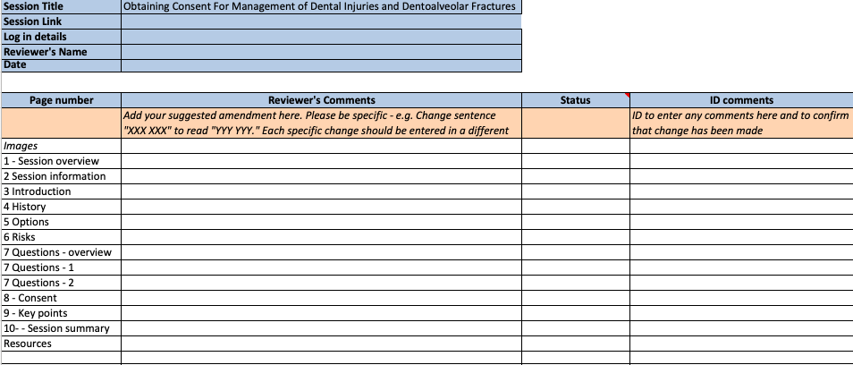

Appendix 3

